

Final Year Project

Rate-Me: A Social Rating Experiment.

Author: Mohamed Ahmed Abdalla Supervisor: Llewelyn Fernandes

Table of Contents

Abstract 4

Keywords 4

Application links 4

Introduction 4

Concept 4

Motivation 4

Problem 5

Technical Implementation Focus 5

Aims and Objectives 5

Project scope 6

Planning 7

Approach 7

Agile Development Techniques 7

Technologies Used 8

High level project plan 10

Methodology 11

User Research Strategies 11

Design Heuristics 11

Stakeholder Analysis 12

Background 12

Early Assumption Testing 12

Justification 13

Inspiration 13

Past and Current Research 14

Limitations of Existing Work 14

Current competition 15

Algorithms 16

Application of the Bayesian Average Algorithm 17

Application requirements 17

Functional Requirements 17

System requirements 18

User requirements 18

Non-functional Requirements 19

Design specification 19

Software requirements 19

User Requirements specification 19

Requirements Specification 20

Functional Specification 20

System Design 21

Use case Diagrams 21

UML diagram 22

Bayesian algoritm Pseudocode 23

Flow chart 23

Experimental design 24

Description of Experimental Process 24

Independent / dependent variables 24

Experimental Confounds 25

Evaluation of Output 25

Development process/ methodology 25

Prototype documentation 26

Core Technologies Used 26

Low fidelity wireframes 26

Mid level-fidelity wireframes 28

High fidelity wireframes 29

Prototype Testing 32

Risk management 32

Ethical considerations 33

Implementation 34

Introduction 34

Application Design preparation 34

Tools Used 36

Iteration and improvements 37

Database Design & Configuration 39

Business Rules/Algorithm 40

Example of the Bayesian Average in "Rate-Me" 41

Comparison of User Ratings 42

Features 42

Index.js 43

Homepage.js 43

Explore.js 44

Rating.js 45

Profile.js 46

Login.js 47

Application screenshots 48

Testing 51

Whitebox testing 51

Blackbox testing 52

User Testing 52

Evaluation 53

Psychological perspective 53

Challenges 54

Analysis of Racial Bias in Ratings 55

Limitations 55

Project outcomes 56

Personal reflection 57

Future enhancements 57

Demonstration video 58

Conclusion 58

References 58

Appendix 59

Table of figures 59

# 

# Abstract

This bachelor's thesis presents the development of a web application. Rate-Me is a social media application that allows users to rate each other dynamically and securely through a user-rating system. This thesis presents the development and evaluation of the web application, including its design, implementation, and user testing.

# Keywords

Rating application, Bayesian algorithm, Ethics, Rate-Me.

# Application links

GitHub link the project: <https://github.com/Mo2225z/Final-Year-Project>

Website link: <http://www.doc.gold.ac.uk/usr/604/>

# Introduction

## Concept

As per my proposal, my aim is to develop a web application that works as a social media application with the added twist of being able to rank other users. I will use social aspects such as social validation recognition, social hierarchy, community building and social competition. In addition to this I will research how social feedback loops influence a user's behaviour, decisions, and social interactions on social media applications, to form of how I will rank each user. the users of this application can use this site to help them decide whether they want to interact with another user based on their score.

I will also use a grading system based off reviews left by users to rank other users. Users will be required to log in via their email and password credentials to leave a review.

## Motivation

There are currently many social web applications on the internet, but none of these platforms provide a way for users to gauge the personality of other users effectively. I seek to bridge this gap with my web application, which introduces a different approach to social interactions online. By creating a ranking system based on a grading scale developed by asking users what they would prefer to see on this application, users can receive and provide feedback on their experiences with others, creating a clearer picture of individual personalities. This feature not only creates a new dimension of social validation and recognition but also promotes a sense of community and accountability. My platform will not only serve as a social space but also as a tool for users to make more informed decisions about who they choose to interact with, based on transparent, peer-generated profiles. My main objective is a technical implementation of rating system then using it for a social experiment to judge people’s reaction to such a system.

## Problem

The central problem to be highlighted throughout my thesis emerges from the limitations of existing social media platforms in effectively gauging and reflecting the true social credibility and personality of users. Current social networking services predominantly rely on superficial engagement metrics such as likes and follower counts, which fail to provide a comprehensive view of an individual’s social behaviour and influence. This gap hinders users from making informed decisions about whom to interact with online, potentially obscuring true social value and leading to a misrepresentation of personal and communal identity.

## Technical Implementation Focus

My project, "Rate Me," is a social experiment designed to innovate social media interactions through my rating system. It focuses on the technical development of a secure platform that enables real-time interactions among users. Central to the experiment is the creation of a fair and effective rating algorithm, while fully complying with GDPR standards. The aim is to explore the social dynamics and behavioural responses to my application.

## Aims and Objectives

**Aim:**

The goal of this project is to create "Rate-Me," a web application that lets users rate one another on social media platforms using a 5-star rating system, thereby improving social media interaction. To provide a comprehensive understanding of online social dynamics, my application aims to add elements of hierarchy and social validation.

**Objectives:**

* **Core Functionality Development**: Construct my application using the best front-end and back-end framework that supports dynamic real-time user ratings.
* **User Experience Enhancement**: Design an intuitive interface that facilitates seamless navigation and interaction, ensuring user engagement and accessibility.
* **Analysis of Social Dynamics**: Investigate how the rating system affects user behaviour and community interactions, with a focus on social credibility and influence.
* **Regulatory Compliance and Scalability**: Ensure the application adheres to GDPR standards and can efficiently handle an expanding user base.
* **Development of a Fair Rating Algorithm**: Create or use an algorithm that accurately reflects user ratings and implement that into my application.

## Project scope

Before I could decide on a minimum viable product (MVP), I developed a backlog to help prioritise what were the most key features needed for this web application to function as I intended. Core functionality would look as follows:



Figure 1. Showcases Main pages.

Then I broke down what is done at each step:

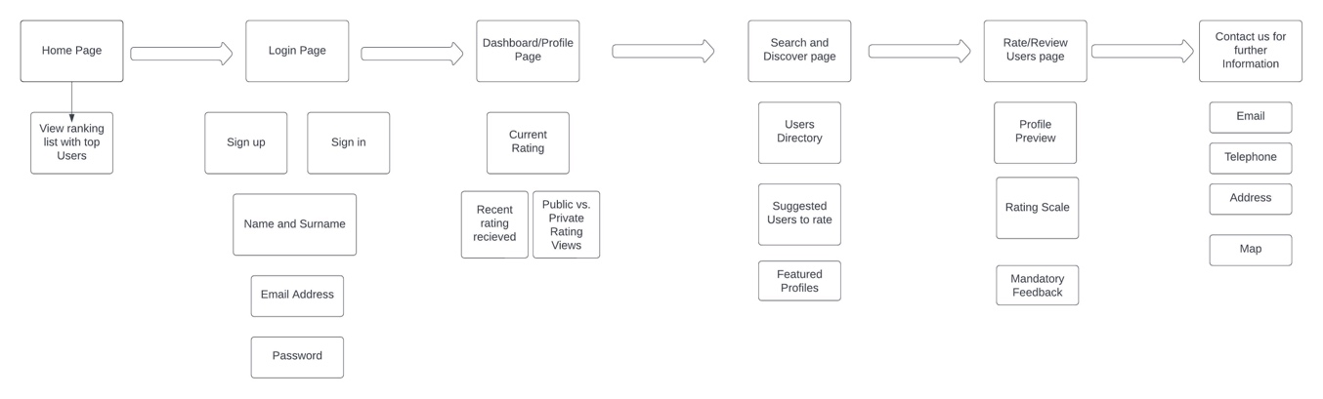

Figure 2. Showcases page sections in detail.

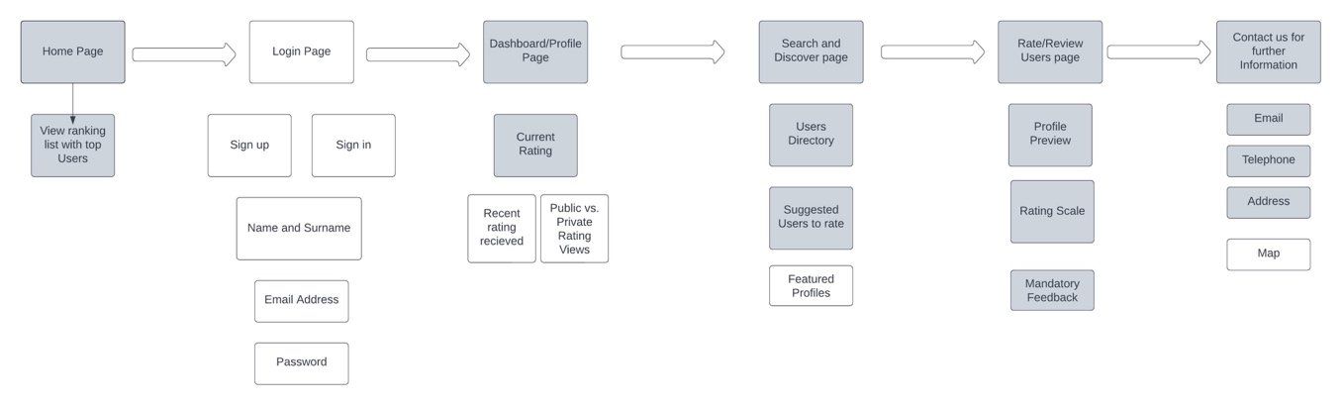From this I prioritised the features that were most important, these are highlighted in grey.

Figure 3. Showcases THE main MVPS.

As a minimum viable product (MVP), I aim to produce a web application that allows users to be able to rate other users using 5-star metric system based on reviews.

**MAIN MVPS**

**Homepage:**

The Homepage offers users a glimpse of the dynamic social environment the web application is fostering. Users will immediately encounter a ranking list that highlights top users based on the 5-star grading system. Visitors can navigate through this page and get a sense of the platform's ethos.

**Dashboard/Profile Page:**

The Dashboard/Profile Page acts as a hub for all user-specific interactions. Here a user can view their current rating, any recent feedback they have received, and adjust settings to determine if their rating is publicly viewable or private. The platform encourages genuine interaction and as such the profile highlights only the most crucial information like names and the ratings received.

**Search and Discover Page:**

The Search and Discover Page aids users in finding and interacting with new profiles facilitated by features like the User Directory, Suggested Users to rate, and Featured Profiles.

**Rate/Review Users Page:**

The Rate/Review Users Page is where the main interaction happens. Users can preview profiles; users can use a rating scale to judge their peers and provide mandatory feedback. This feedback loop not only keeps the rating system transparent but also provides invaluable insights to users about out how they are perceived.

**Contact Page:**

Users can contact me via the details given on the page. As a minimum viable product, I will include email, telephone, and an address.

**ADDITIONAL FEATURES**

If the initial MVP for this project is met, I will aim to develop the login system that requires the user to enter their credentials so that I can verify them. This will help avoid discriminatory reviews being left by the user. Having verified users also protects the integrity of the site and information submitted.

# Planning

## Approach

My intention was to meet my supervisor on a weekly basis, this would’ve given me time to work on my tasks and the meetings would be an opportunity for troubleshooting and to review if my current plan was working or if any changes needed to be made.

## Agile Development Techniques

I looked at agile development techniques to help me plan how I would work on this project. I decided that Kanban’s and Test-driven development (TDD) were important for me to achieve my end goal. Using a Kanban would allow me to visualise how much progress I was making and keep track of work that needs to be done.

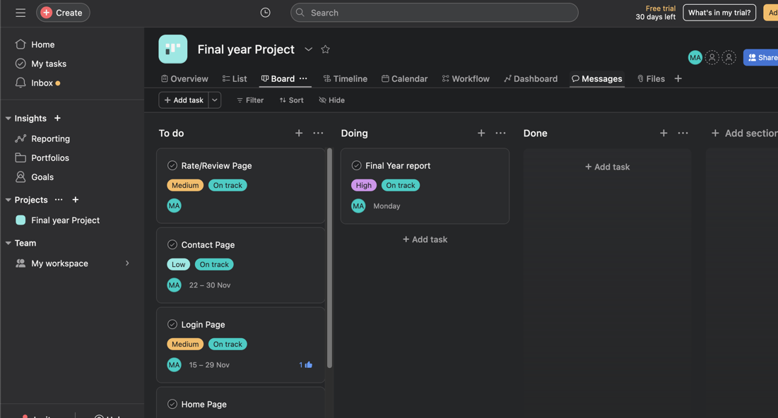

Figure 4. Showcases kanban project management tool.

I created a first Kanban using a platform called Asana. Here, I can set deadlines for individual tasks, set follow-ups task and much more. Test driven development was an important part of my development, used regularly to measure my progress and functionality of the web application. For each stage of the TDD I needed to write some tests that I expected to fail, I ran the tests against my software and refactored the code accordingly.

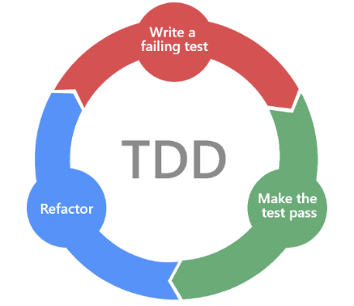

Figure 5. Showcases application cycle.

I used User-feedback as part of my testing as I wanted to ensure the user requirements are being met and that I was working in line with the proposal.

## Technologies Used

I used GitHub for version control. I created a repository and uploaded the iterations of my MVPS here.

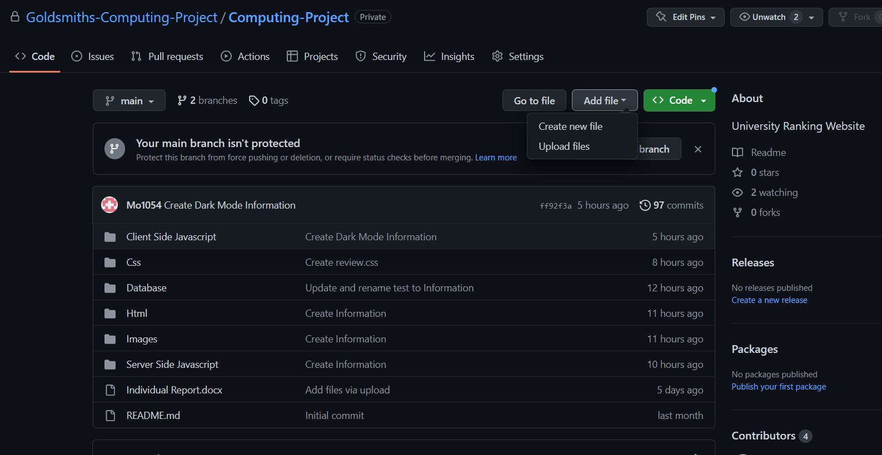

## High level project plan

Since this project makes use of the agile method, some tasks are fully extended to the very end of the testing phase. This Gantt chart indicates the constant improvement and refinements of its features and UI. This Gantt chart will hopefully serve to keep organised throughout the project.

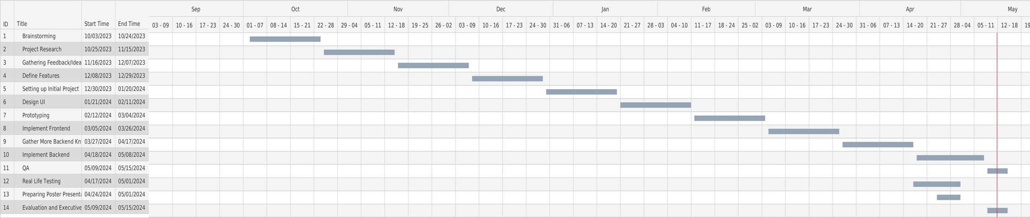

Figure 6. Showcases project plan.

# Methodology

## User Research Strategies

**Online survey:**

For my project, I will employ surveys to collect quantitative data from a broad spectrum of users of the "rateMe" application. These surveys will evaluate aspects such as user satisfaction, interface usability, and functionality. The aggregated data will enable statistical analysis, allowing me to identify prevailing trends and areas requiring enhancements.

**Focus groups:**

Alongside surveys, I will conduct focus groups to gather qualitative insights from users. These sessions will involve interactive discussions with selected participants to delve into their personal experiences and perceptions of the platform. This method will provide a deeper understanding of user interactions and emotional responses to my application.

**Expert consultation:**

In addition to surveys and focus groups, I will engage in expert consultation by regularly discussing the development progress and findings with my supervisor. This interaction will allow me to leverage academic and industry expertise to validate the research methodology and interpret data collected from my application. Through these consultations, I will gain insights and practical advice on improving the project's design and functionality.

## Design Heuristics

When thinking about design heuristics I wanted to make sure that my web application met the following criteria by achieving the following targets below. By using design heuristics, I can approach problems in a systematic way and generate solutions that are more likely to meet the needs of users and stakeholders. This should result in a better design outcome.

Simplicity

I want to keep the design of my web application simple, so that it is more accessible and easier to understand and navigate for the user.

Feedback

The design should provide clear feedback to the users, to help them understand the impact of their actions whilst navigating the site and how the system works.

Affordances

I want to ensure that the interface is clear and intuitive to the user.

Consistency

This is an important aspect of my design, it needs to be consistent in its colours, typography, and layout, to create a unified and cohesive visual expression.

Error prevention

I want my design to guide users towards correct actions and prevent mistakes, this ties in with the simplicity; having an easy to navigate system will help prevent errors by the user.

## Stakeholder Analysis

I initially identified the main stakeholders to be the public businesses and Service Providers and Government and Regulatory Bodies.

**Users**: The primary stakeholders. Their social status is dictated by their ratings on the app. This includes every individual in society who engages with the app for social standing and opportunities.

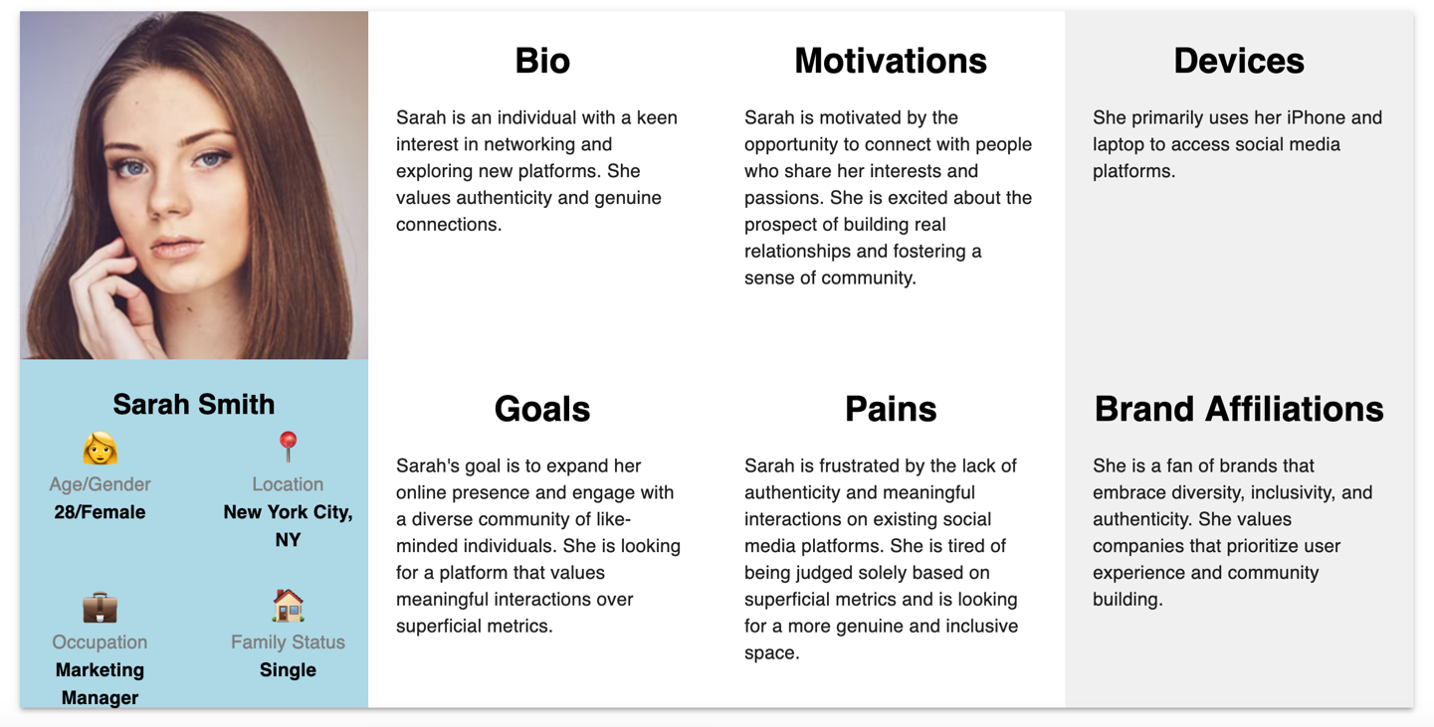

Figure 7. Showcases user persona.

**Businesses and Service Providers**: Businesses that could use the app's rating system to determine the eligibility of customers for services or discounts. The business operations and customer relations are significantly influenced by the app.

**Government and Regulatory Bodies**: The government could use the app as a tool for social control. They could impose regulation, impacting policies and legal frameworks.

# Background

## Early Assumption Testing

The early assumption testing for the web application is critical to validate the idea that users desire a more a quantifiable and open way to understand the social credibility of other users. I will begin with the idea that a user's online interaction can be reliably quantified into a rating that can accurately reflect their social behaviour and reputation. To test this, I will conduct surveys and interviews with potential users to measure their perception of such a system and their willingness to participate in the importance they place on others' opinions in online digital interactions.

## Justification

Currently, the social media market has many competitors with their own applications ranging from broad web networks like Facebook and Twitter to smaller communities focused on specific interests like Discord for gaming and 4chan for political issues. I would say that the drastic changes to these platforms also created some challenges. These challenges are the nature of user interaction and the nature of the feedback systems in place.

These traditional social media platforms rely primarily on basic metrics like likes, shares and follower counts to measure engagement. The metrics are useful for measuring user engagement but often provide little insight into the quality and depth of user engagement. Many of these platforms do not handle anonymity that well, leading to issues like trolling and lack of accountability among users.

My project is initiated as a technical implementation with the secondary goal of addressing the inadequacies of traditional social media metrics that fail to capture the genuine social behaviour and influence of users.

## Inspiration

**Online Reputation Management (ORM) Systems**: ORM systems in e-commerce provide a framework for understanding how ratings and reviews can influence user perception [1]

**Peer Review Systems in Academia**: The peer review process, though not without its flaws, offers insights into structured feedback and ranking mechanisms [2]

**Gamification in social media**: The concept of incorporating game-like elements into non-game contexts (e.g., user rankings) can increase user engagement and motivation [3]

**Black mirror:** The popular television programme black mirror was a primary inspiration. Nosedive, created by Joe wright details the corruption of society caused by social media applications. Nosedive, being the primary web application that allows users to rate each other on a 5-star metric system.

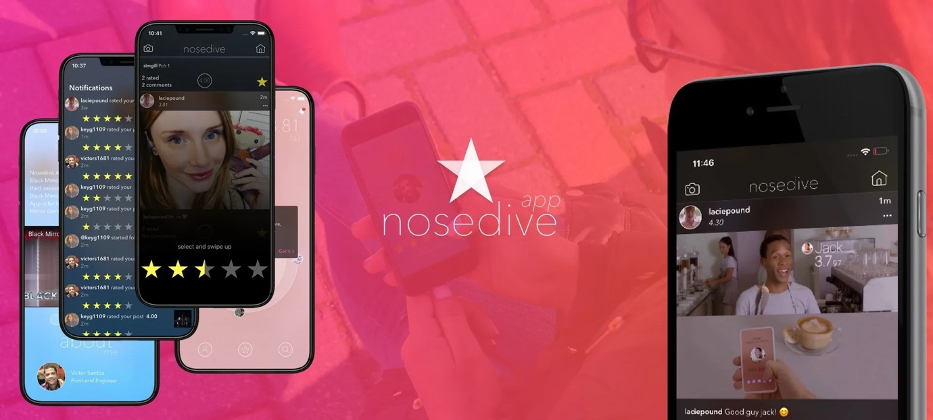

## Past and Current Research

**Social Media Interaction Models**: Traditional models of social media engagement are limited in their ability to convey the complexities of user interactions [4] These models lack mechanisms for accurately reflecting users' social credibility and the quality of interactions.

**User Feedback and Online Reputation Systems**: Research in online reputation systems, like those implemented in e-commerce sites (e.g., eBay, Amazon), shows the potential of user feedback in building trust and credibility [5]. Applying these principles to social media can pioneer a new approach to understanding social dynamics.

**Psychological Impact of social media**: Studies have shown that social media can significantly influence users' self-esteem and social behaviour, often driven by the need for social validation [6].

## Limitations of Existing Work

**Limitations of Current Social Media Models**: While traditional social media platforms are effective for broad networking, they often fall short in fostering deeper, more meaningful interactions [4]. Additionally, issues like anonymity lead to challenges like trolling and lack of accountability.

**Contradictions in User Feedback Systems**: Although user feedback can build trust, it can also lead to biases and unfair characterizations, especially in the absence of robust verification mechanisms [7]

**Developing Areas**: Incorporating psychological and sociological insights into social media design is an emerging field, offering opportunities to create more empathetic and socially responsible platforms [8]

**Dead Ends**: Over-reliance on quantitative metrics (like number of likes or followers) has been criticized for oversimplifying complex social interactions [9]

## Current competition

**Facebook:**

It was founded in 2004, and the headquarters are in Menlo Park, California, continues to dominate social media with 3 billion monthly users. It integrates various social feedback mechanisms such as likes and comments that indirectly facilitate user ratings. In 2022, it contributed significantly to Meta's earnings of $114.45 billion. [11]

**TikTok:**

It was founded in 2016 by ByteDance, TikTok has emerged as a significant player with 1.2 billion users, focusing on short-form video content. While financials are private, ByteDance's revenue was around $80 billion in 2022, with TikTok contributing to this substantial income​. [11]

**LinkedIn**:

It was founded in 2003 and headquartes in Sunnyvale, California, LinkedIn is networking platform with over 424 million monthly users. It allows for professional endorsements and skill ratings, influencing career opportunities and industry networking​. [12]

**Comparison table**

| **Platform** | **Founded** | **Headquarters** | **Monthly Users** | **Notable Features** | **Strengths** | **Weaknesses** |
| --- | --- | --- | --- | --- | --- | --- |
| **Facebook** | 2004 | Menlo Park, CA | 3 billion | Likes, comments, groups | Extensive global reach, varied tools for user engagement | Declining popularity among younger demographics, privacy concerns |
| **TikTok** | 2016 | Beijing, China | 1.2 billion | Short-form video, "For You" algorithm | Highly engaging content, strong appeal to younger users | Content moderation issues, data privacy concerns |
| **LinkedIn** | 2003 | Sunnyvale, CA | 424 million | Professional networking, endorsements | Professional focus, reliable for career networking | Less frequent daily use, limited to professional content |

**Contextual Placement within the Field:**

The project I am developing aligns itself at the intersection of social media, online behaviour, and user experience design. It will contribute to the ongoing discourse about the role of social media in shaping online identities and interactions. I have introduced a novel user ranking mechanism. This challenges the conventional engagement metrics and opens avenues for more meaningful online social experiences. Through a social experiment using this Rate-me rating system my project will explore its impact on user behaviour and the psychological effects of social rankings, providing fresh insights into how such dynamics influence online community interactions and individual self-perception.

## Algorithms

**Potential Algorithms for rating system**

**Weighted Moving Average (WMA) Algorithm:**

* Ratings are not treated equally. More recent ratings have a higher weight than older ones.
* Helps in evolving the user's score dynamically with time.
* Formula: WMA=∑i=1nwi×xi∑i=1nwiWMA=∑i=1n wi ∑i=1n wi ×xi
* Where w is the weight and xi is the rating

[13]

**Elo Rating System:**

* Originally developed for chess, this system adjusts ratings based on the difference between expected and received scores.
* Good for pairwise comparison if your system involves one user rating another directly.
* The difference in ratings between two users serves as a predictor for the outcome of a rating.

[14]

**Bayesian Average:**

* Used to avoid extreme ratings when there's insufficient data.
* It considers the global average rating and the number of ratings a user has.
* Good for startups or new users with few ratings

[15]

## Application of the Bayesian Average Algorithm

The Bayesian Average algorithm is a method grounded in Bayesian statistics, enhances rating systems by stabilizing averages in cases of sparse data. It adjusts ratings by incorporating the overall average and the number of ratings, providing a more balanced measure. [16]

**Usage in my Project:** In my application the Bayesian Average will be used for fair and accurate user ratings, particularly for new or infrequently rated users. The Bayesian Average algorithm was chosen because it provides a balanced and representative ratings, especially beneficial for new or infrequently rated users. It counters the skew from limited ratings by incorporating the overall average and rating frequency.

**Bayesian metric table:**

| **Component** | **Type** | **Description** |
| --- | --- | --- |
| **Individual Ratings** | Quantitative | These are specific numerical ratings assigned by users, such as a 3.4 on a scale from 1 to 5. |
| **Number of Ratings** | Quantitative | Shows the total count of ratings each user has received, which is needed for weighting individual scores. |
| **Overall Average Rating** | Quantitative | The mean rating is calculated across all users, used to stabilize ratings particularly in sparse data cases. |
| **Feedback/Comments** | Qualitative | The textual feedback is provided by users alongside their ratings |

# Application requirements

## Functional Requirements

**User Ranking System:** A core feature where users can rate others using a 5-star system based on their interactions. Using NoSQL's flexible schema for storing and retrieving user ratings and reviews and implement algorithms in JavaScript for the 5-star rating system.

**User Authentication:** The users must log in with email and password credentials to ensure accountability and prevent anonymous reviews. I will develop authentication processes using Node.js with email and password credentials for secure logins.

**User Profile Management: T**heusers be able to create, edit, and view their profiles. This is including their ratings and feedback received. Use NoSQL databases to store user profile information, allowing for flexible data models as the data grows.

**Search and Discovery:** Users should be able to search for other users, view suggested profiles and explore featured profiles.

**Rating and Review System:** Users can rate others and leave feedback. I will design the backend logic in Node.js for users to rate and review others then store this data in the NoSQL database.

**Contact system:** The users need a way to contact support. This will be through the contact page. I will create a contact form feature using JavaScript and Node.js, with entries stored in NoSQL.

## System requirements

**Compatibility:** Ensure the application is compatible across different browsers and devices. Focusing on responsive design with JavaScript.

**Scalability:** Use Node.js and NoSQL databases like MongoDB for their scalability in turn handling an increasing load with efficient data handling and retrieval.

**Security:** Implement robust security measures in Node.js in turn safeguarding user data, especially with the use of email and password credentials.

**Performance:** I will optimize JavaScript and Node.js code for fast response times, ensuring efficient server-side processing.

**Data Storage:** Using a NoSQL database for flexible and scalable data storage.

## User requirements

**Ease of Use:** The JavaScript on the front end will be designed to be user-friendly. This will ensure the user interface is seamless and versatile.

**Accessibility:** I will make sure to adhere to the web accessibility standards in my JavaScript frontend development.

**Feedback System:** I will use JavaScript to provide clear feedback to users on my web application.

**Privacy Controls:** I will implement privacy settings in the application, allowing users to control their data visibility, managed through Node.js and stored in NoSQL.

**Reliability:** I will ensure the backend processes in Node.js are very robust and error-free for reliable application performance and in turn this will help combat latency issues with the users on my web application.

## Non-functional Requirements

**Usability:** I will create a user-friendly interface with JavaScript, prioritizing ease of navigation and clarity.

**Performance Efficiency:** Optimize Node.js server-side operations and JavaScript execution for efficient application performance.

**Maintainability:** Write clean, modular, and well-documented code in Node.js and JavaScript, ensuring easy maintenance and updates.

**Security:** I will implement comprehensive security measures in both Node.js server-side logic and JavaScript frontend, safeguarding against vulnerabilities.

**Accessibility**: As stated previously, the site should be accessible to users with disabilities, adhering to WCAG.

**Compliance:** The site should comply with the relevant laws and regulations relating to privacy, data protection and security. Inappropriate and offensive content will be filtered.

# Design specification

**Evaluation plan:**

To properly evaluate my app, I will provide users with and without documentation to test how intuitive my app is. Which will then provide me with the relevant feedback for me to improve. I will also provide questionnaires to evaluate my findings and gain further market research.

## **Software requirements**

### User Requirements specification

I have identified a set of user requirements designed to guarantee that the application is safe and efficient while also being simple and easy to use. I've listed every necessary feature below. These features range from interactive ratings and secure logins to extensive privacy controls.

**User requirements:**

* Intuitive Interface: My app should be straightforward and easy for users to navigate.
* Secure Login: creating a secure and reliable user login.
* Interactive Rating Feature: A system enabling users to assign ratings to their peers, using a 5-star scale.
* Review Functionality: Allowing users to provide feedback accompanying their ratings.
* Discover and Explore: Tools for users to find and connect with new profiles.
* Profile Customization and Viewing: Enabling users to modify their profiles and view their interaction history, including received ratings and feedback.
* Control over Privacy: Users should have the ability to manage the visibility of their personal ratings and feedback.
* User Contact Feature: A section for users to seek support or assistance.

### Requirements Specification

I've developed requirement specifications for my application. These consist of effective data management, instantaneous updates, and widespread device and legal framework compatibility. I’ve gone over each of these requirements in detail below:

* User-Friendly Design: An accessible and straightforward design for all user interfaces.
* Storage and Handling of Data: Employing NoSQL databases to manage user profiles, interactions, and associated data.
* Adaptability and Growth: Ensuring the system can accommodate an increasing user base.
* Data Protection: Stringent security protocols to safeguard user information.
* Universal Compatibility: I will ensure consistent functionality across diverse devices and web browsers.
* Dynamic Rating Updates: System designed to show rating changes in real time.
* Legal Compliance: My application will adhere to prevailing data protection and privacy regulations.

### Functional Specification

**Login Module:**

* + Implementation of secure login.
  + Authentication process to verify the identity of users.

**Rating and Review Module:**

* + Users can rate others on a scale of 1 to 5 stars.
  + Mandatory feedback section for any rating given.
  + Algorithm to calculate and display average user ratings.

**User Profile Module:**

* + Personalized user profiles showing ratings, feedback, and basic information.
  + Options to edit profile details and privacy settings.

**Search and Discovery Feature:**

* + Search bar to find users.
  + Suggested users feature based on user interactions and interests.

**Homepage and Dashboard:**

* + Dynamic homepage displaying top rated users and recent activity.
  + Personalized dashboard for users to view their ratings and feedback.

**Contact Page:**

* + Contact form linked to email and telephone support.
  + Map location provided on the web application.

## System Design

### Use case Diagrams

Use case diagram Showcases the rating of other users on the web application.

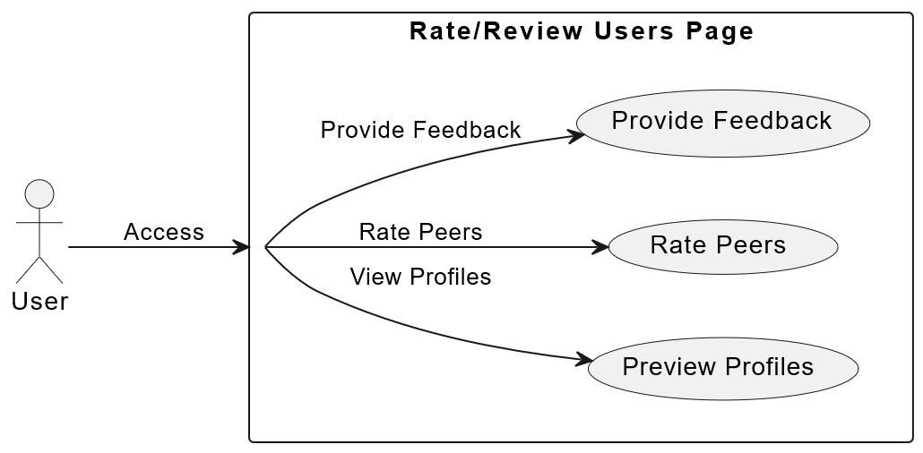

Figure 8. Showcases review/rating usecase.

Use case diagram Showcases the user using the search and discover page to find user ratings.

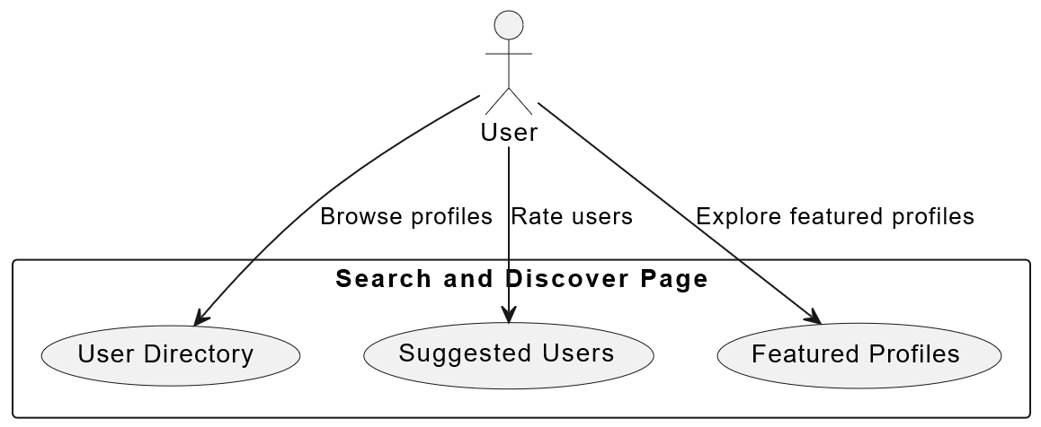

Figure 9. Showcases search and discover use case.

### UML diagram

The diagram below presents a Unified Modeling Language (UML) class diagram for the proposed social rating system. This system encompasses several key components aimed at managing user interactions and ratings within my web application. The central class is User, which holds attributes such as userID, username, password, email, rating, and a feedbackList.

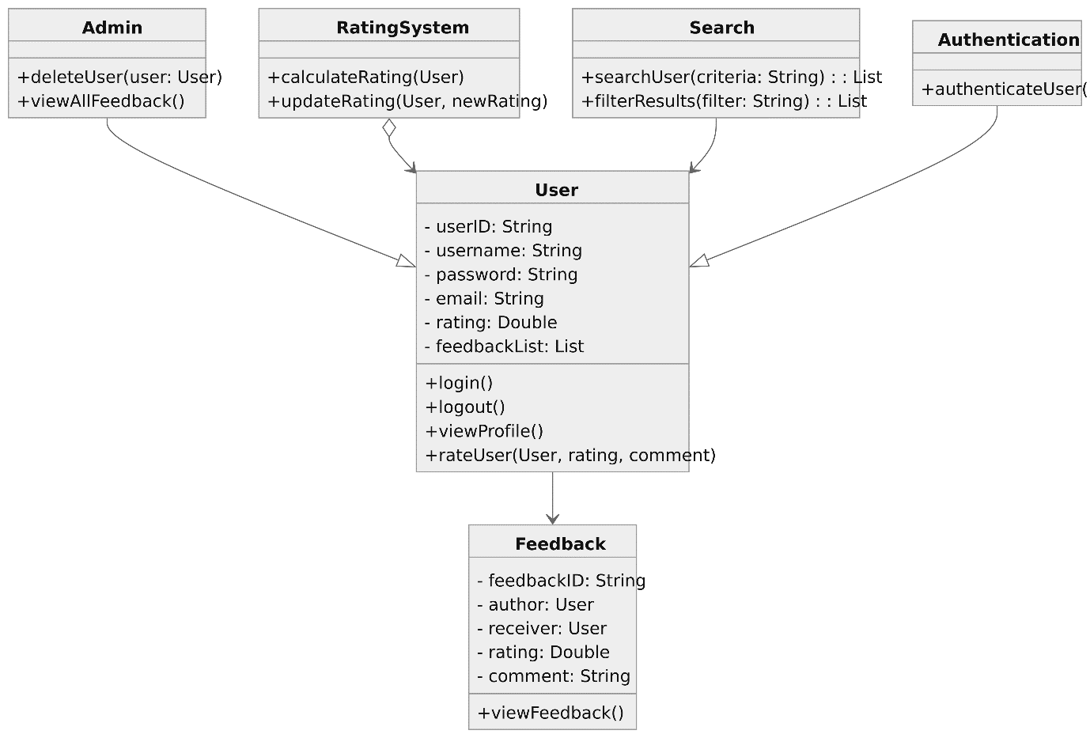

Figure 10. SHOWCASES UML DIAGRAM.

### Bayesian algoritm Pseudocode

Pseudocode for Bayesian Average algorithm which is used to avoid extreme ratings when there's insufficient data:

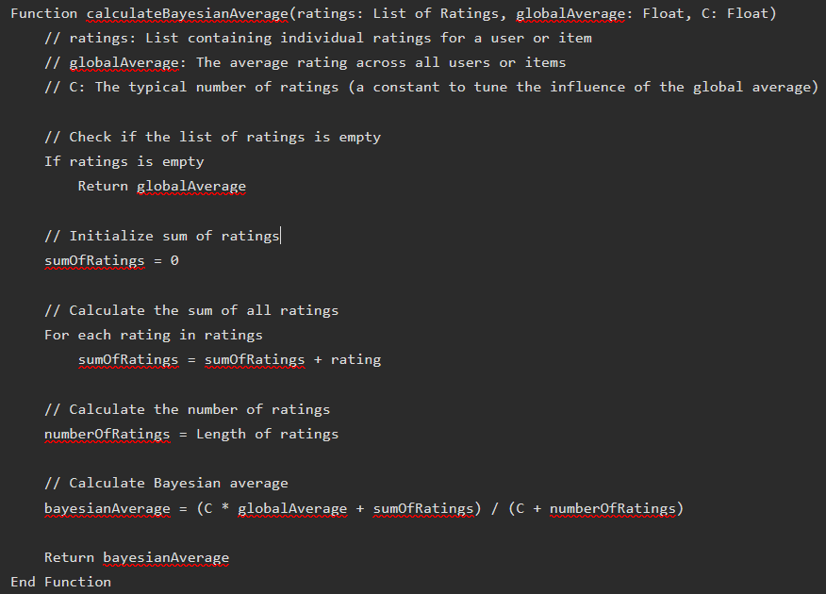

Figure 11. Showcases BAYESIAN ALGORITM PSEUDOCODE.

### Flow chart

The flowchart below illustrates the user journey within the social rating system for rating and reviewing peers:

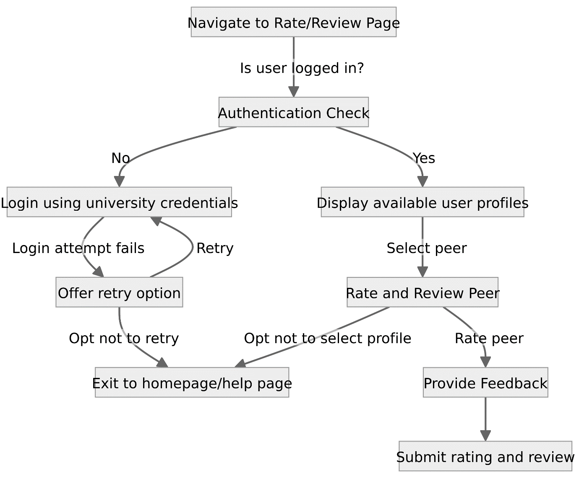

Figure 12. Showcases review/rate flowchart.

## Experimental design

### Description of Experimental Process

**Experiments:**

* I will conduct a session to familiarize users with RATE-ME's features and the purpose of the study.
* I will allow participants to use RATE-ME for a set period, encouraging them to explore all features.
* I will monitor the user interactions within the app, focusing on how they engage with the 5-star rating system and other functionalities in the app.
* At the end of the usage period, I will collect user feedback through surveys, interviews, or focus groups.

### Independent / dependent variables

**Independent Variables:**

* Features within the app (e.g., the 5-star rating system).
* User authentication method (the email and password credentials vs. standard methods).

**Dependent Variables:**

* User engagement (measured by time spent, frequency of use, interactions).
* User feedback and perceptions (I will gather from post-use surveys or interviews).

### Experimental Confounds

**User Preferences:** Individual preferences for certain types of social media interactions.

**Technical Variability:** Differences in user experience due to device type or internet connection.

**External Social Influences:** Any current social media trends or events that might influence user behaviour.

### Evaluation of Output

**Interaction Data Review:** I will analyse how users interact with the app, focusing on engagement with the rating system.

**User Feedback Analysis:** I will assess feedback for insights into user satisfaction, perceptions, and suggested improvements.

**Comparative Review:** I will examine differences in user behaviour and feedback based on the independent variables.

**Technical Assessment:** Assess any reported technical issues or challenges faced by users during the testing period.

### Development process/ methodology

For the development of Rate-me, I will be using Node.js for its efficiency in back-end processing, crucial for real-time user interactions. The front-end will be powered by JavaScript, ensuring a seamless and responsive user experience. I will employ a NoSQL database like MongoDB for its flexibility with diverse data types which is needed for managing user profiles, ratings, and reviews.

For me to refine the user rating system, algorithms such as Weighted Moving Average and Elo Rating System will be used, providing a dynamic and fair representation of user profiles. The development approach will be guided by Test-Driven Development (TDD) [17], ensuring high-quality and efficient code.

I will use GitHub as a version control system, facilitating smooth collaboration and rapid iterations. The user authentication will be integrated with email and password credentials to ensure security and credibility.

In post-development, the app will undergo rigorous testing, including personal testing, user testing sessions, and surveys to gather broad user insights. This will be complemented by integration testing to ensure seamless functionality. This comprehensive approach aims to deliver a unique and engaging social media experience through Rate-me.

# Prototype documentation

## Core Technologies Used

* **Agile Development Practices**: For employing methodologies like Test-Driven Development (TDD) and regular user testing sessions.
* **Figma**: I used it for the design and prototyping of my application.
* **GitHub**: I will use it for version control and collaborative development.
* **Wireframe.cc**: I used it for creating low-fidelity wireframes. It was useful for iterating over and refining my design.

## **Low fidelity wireframes**

The Low fidelity wireframe acts as my initial concept of the web application. This will allow me to visualize my concepts and ideas in early stage and to see if I have any improvements or innovations. Also, it helps me to focus on the functionality of the website instead of the look of it.

This was the first iteration of the login page; through user feedback I will make improvements to the design.

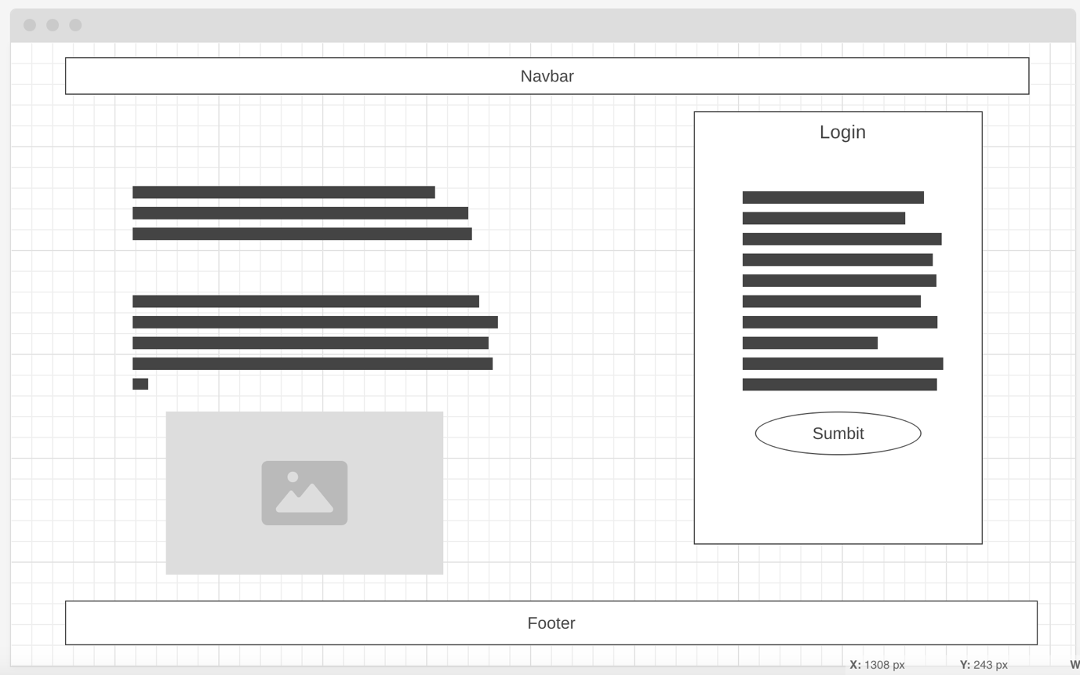

Figure 13. Showcases LOGIN LOW FEDILITY WIREFRAME

This is my first idea of how the homepage would look, there would be a background image then a list of top users below.

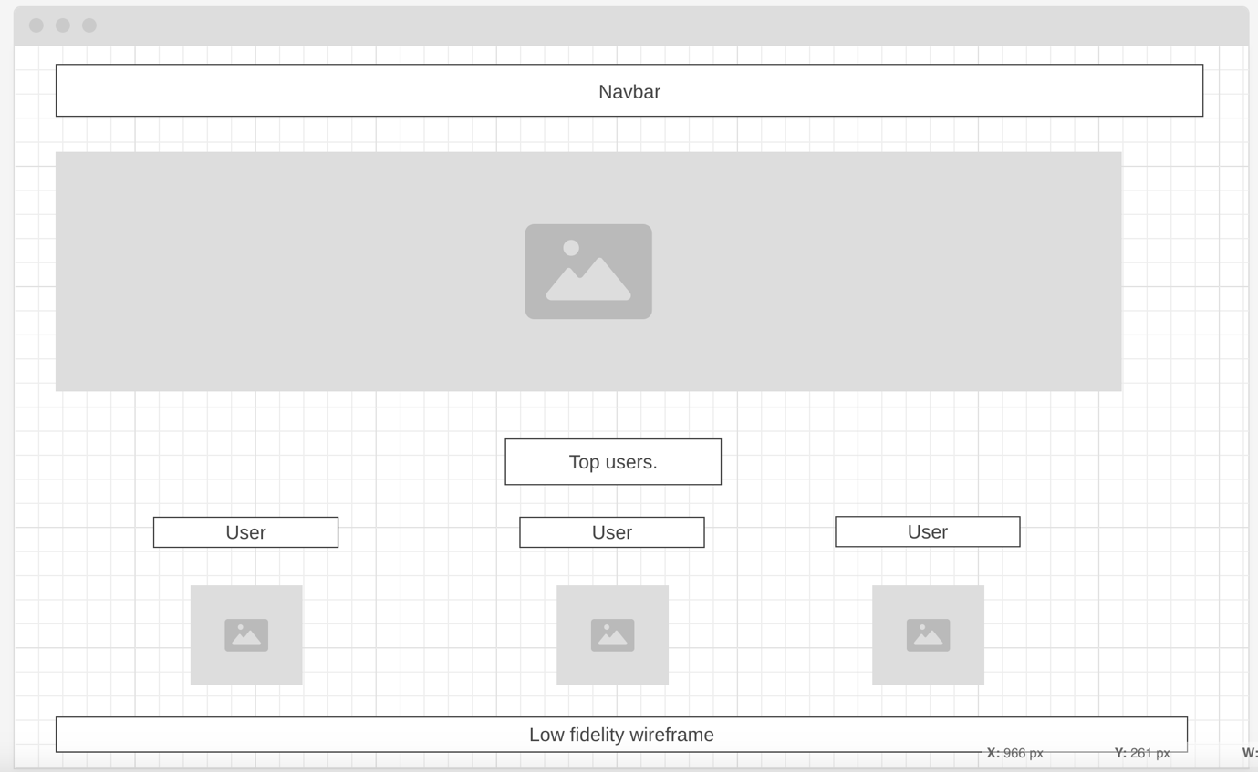

Figure 14. Showcases HOMEPAGE LOW FEDILITY WIREFRAME.

I looked at the feedback from my questionnaire, in particular the comments regarding navigation and information. I decided that I needed to make the homepage more visually engaging as the first point of contact, and that the necessary information was being projected to the user.

## Mid level-fidelity wireframes

I designed mid-level wireframes before moving onto the high-fidelity wireframes to gain further user testing before developing a full prototype, below you will find the screenshots of that.

This is the login page for the mid-level wireframe prototype.

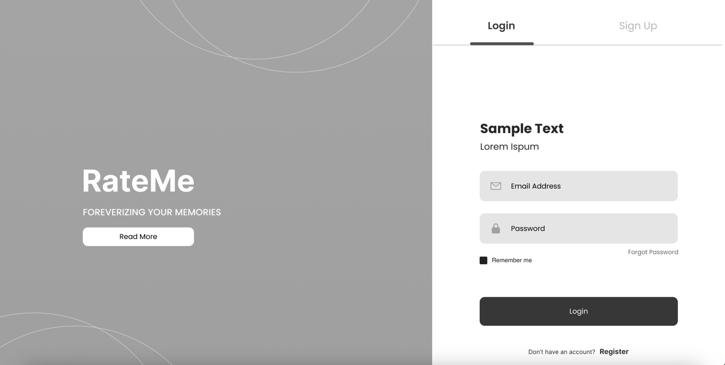

Figure 15. mid-level login page wireframe

This is the home page for the mid-level wireframe prototype.

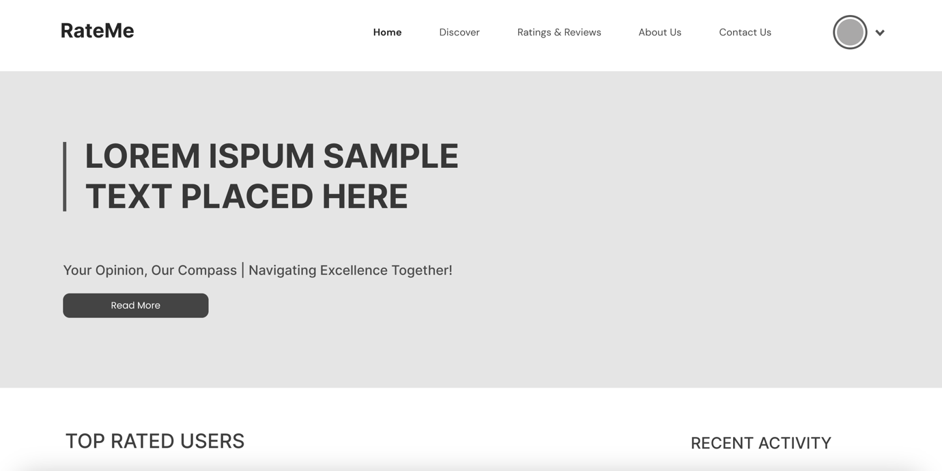

Figure 16. MID-LEVEL homepage wireframe.

**First prototype link:** [**https://www.figma.com/proto/Wn5fdgwIUE9bCXyGAhH83i/Mid-level-prototype?type=design&node-id=1-1099&t=Z9H45UIFX3ZsTdQi-1&scaling=min-zoom&page-id=0%3A1**](https://www.figma.com/proto/Wn5fdgwIUE9bCXyGAhH83i/Mid-level-prototype?type=design&node-id=1-1099&t=Z9H45UIFX3ZsTdQi-1&scaling=min-zoom&page-id=0%3A1)

## High fidelity wireframes

For the final iteration of my prototype, I conducted user testing on the colour scheme that would be utilized for my application. Based on that feedback, I developed the high-fidelity prototype, which will be showcased below.

This is the login page for the high-fidelity wireframe prototype.

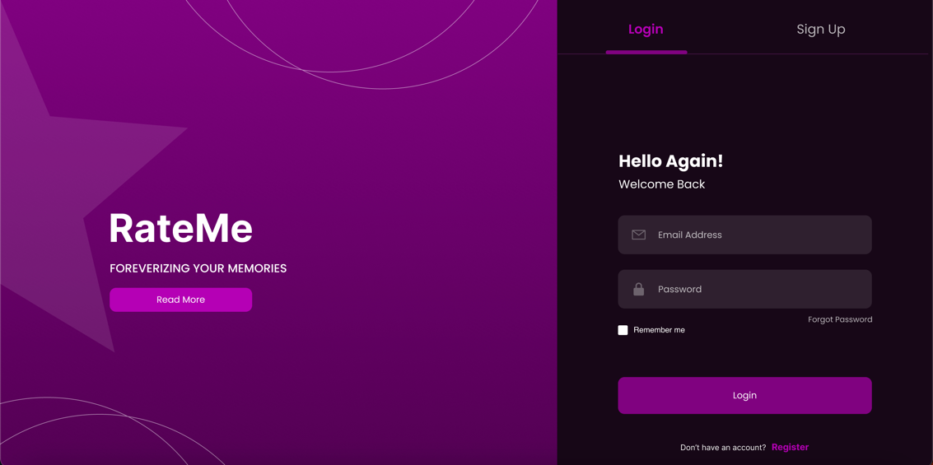

Figure 17. Showcases high-fedility log in page.

This is the home page for the high-fidelity wireframe prototype.

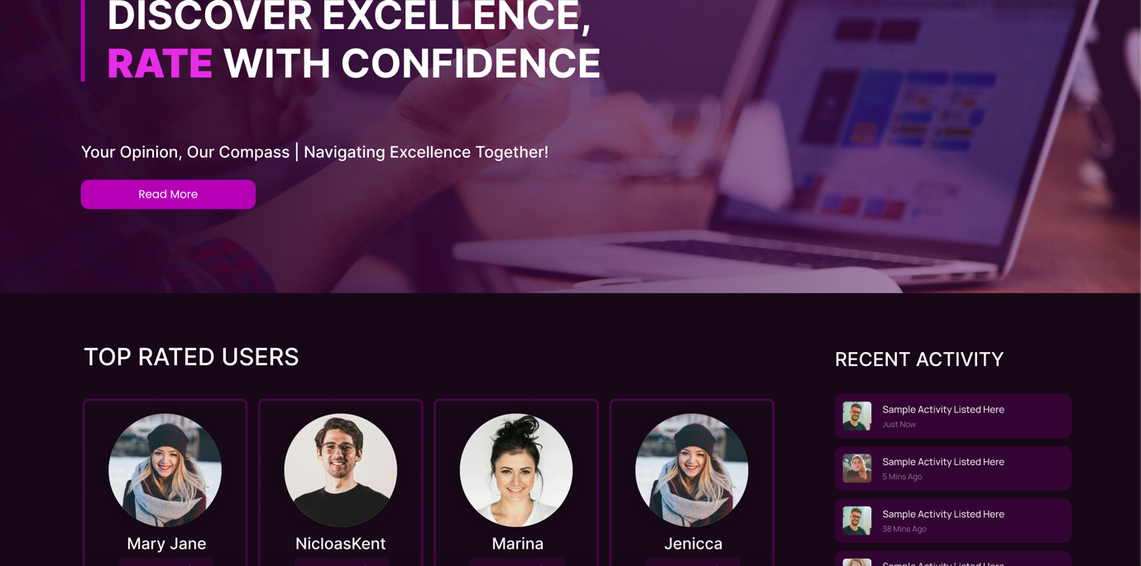

Figure 18. shows homepage HIGH-FEDILITY.

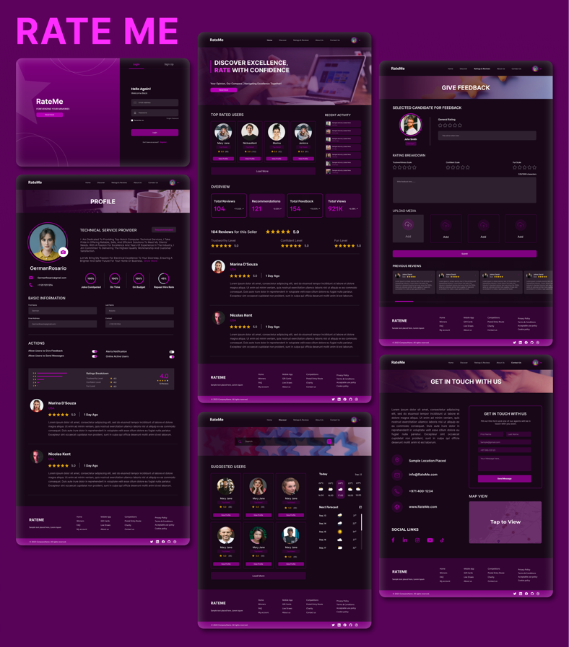

**Prototype link:**  <https://www.figma.com/proto/bjknawJ9Jch1TvBYVT3Jk9/High-level-prototype?node-id=1-2348&t=9PZWoge2SrKQejKn-1&scaling=min-zoom&page-id=0%3A1>

**Feedback for design table**

Table 1. Showcases design feedback.

| **Design Element** | **Colour Scheme** | **User Feedback** |
| --- | --- | --- |
| **Overall Layout** | Purple and black | Users appreciated the professional and calming effect of the colour scheme, enhancing the usability of the interface. |
| **Navigation Bar** | Black | Feedback highlighted the contrast and visibility provided by the dark blue. |
| **Buttons** | Purple and black | Users found the purple buttons on a white background to be appealing and easy to locate. |
| **User Profiles** | Dark Grey | Positive remarks were made about the dark gray background., which reduced eye strain and improved text readability. |
| **Ratings Display** | Yellow Stars | The use of yellow for the rating stars was universally liked for its traditional association with ratings and ease of assessment. |
| **Text Colour** | Black on White | High contrast between black text on a white background was well-received for clarity and readability. |

**Bayesian algorithm implementation:**

The figure belowshows the Bayesian Average function, a method to estimate an average rating by combining individual item ratings with a global average. The function accepts three parameters: an array of rating objects (ratings), a predetermined global average rating (globalAverage), and a confidence value (confidence). Each rating object in the ratings array contains a rating value and a count indicating the number of times that rating was given.

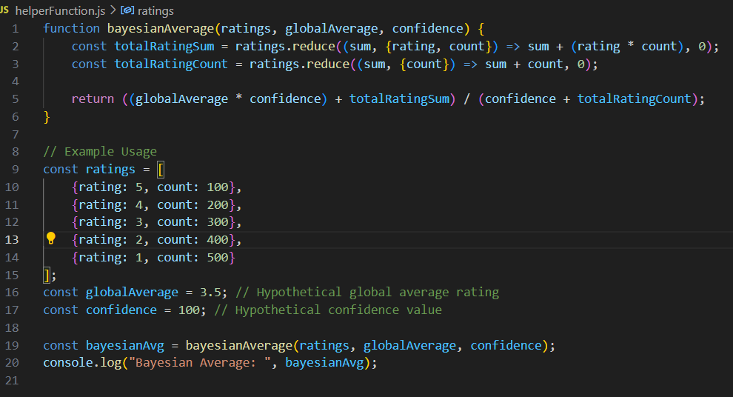

Figure 19. Showcases Bayesian algorithm.

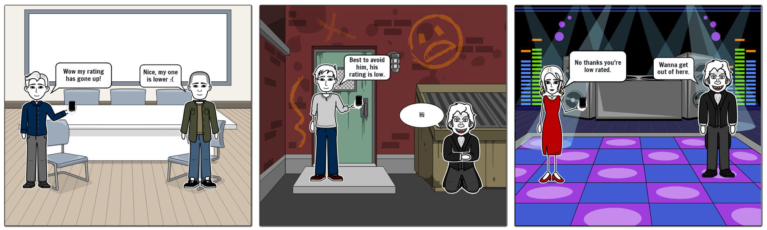Storyboard: The storyboard below will showcase how the application will be used in a real-world context.

Figure 20. Showcases storyboard.

## Prototype Testing

I used a thorough testing approach, including automated testing, manual testing, and user experience evaluation, when creating my Figma prototype to maximize functionality and user experience.

**Automated Testing:** I automated the process of confirming design consistency among elements and interactions by using Figma plugins. This process made sure that fonts, colours, and alignment were all consistent, which allowed for easy modifications and preserved the cohesiveness of the design language.

**Manual testing:** I tested the prototype in-person by navigating it to simulate user interactions and looking for usability problems like broken links or ambiguous navigational paths. Validating the interactive components and the design's overall workflow required in this procedure.

**User Experience Evaluation:** User behaviour and preferences were directly observed during real-time user testing sessions. With an emphasis on raising overall user satisfaction and engagement, observing users interact with the prototype validated successful design features and revealed important areas for improvement in my application.

### Risk management

**Prototype Development:**

**Challenges:**

* The integration of certain advanced features like the Bayesian Average and Weighted Moving Average algorithms faced initial problems but has been fixed.

I made some minor deviations from the initial proposal were made based on preliminary testing feedback and practical considerations.

**Testing and User Feedback:**

* I did manual testing on various browsers and devices has provided valuable insights into the front-end user experience and interface design.
* The user feedback particularly regarding the usability and interface design has led to iterative improvements in the application.

**Risk Management:**

* I identified risks that include potential technical glitches and data security concerns. I have implemented robust security measures in my Node.js backend and will continue to monitor and address any vulnerabilities.
* I have contingency plans to tackle unexpected technical challenges and data breaches.

**Risks table:**

Table 2. Showcases risk table.

| **Risk** | **Impact** | **Mitigation Strategy** |
| --- | --- | --- |
| **Technical Failures** | High (Could affect stability and integrity) | I will implement regular system backups and error handling. |
| **Data Breach** | Critical (Could compromise user privacy and violate GDPR) | The data will be deleted after project completion to avoid this. |
| **Project MVPS are not met.** | Moderate (Could impact the project's success) | I will develop a schedule to make sure I finish the tasks on time. |
| **Rating Inaccuracy** | High (Could undermine the system's credibility) | I will create an algorithm that enables users to report unfair ratings. |
| **Regulatory Non-Compliance** | Critical (Could result in legal repercussions) | I will regularly consult with my supervisor to ensure it follow regulatory practices. |

### Ethical considerations

**Involvement of Human Participants:**

* Since my application allows users to rate each other using a 5-star grading system then it directly involves human participants. This introduces ethical concerns related to social impact, privacy, and potential emotional or psychological effects on users.
* Ethical concerns may arise from the way users perceive and react to ratings. High or low ratings could impact a user's self-esteem or social standing within the community.
* To address this issue, I need to make guidelines and rules to prohibit abusive conduct on my web application.

**Handling of Personal Data (GDPR Compliance):**

* My application requires users to log in using email and password credentials which means handling sensitive personal data. Under GDPR [18], I am obligated to ensure the security and privacy of this data.
* I should include clear consent forms explaining how user data will be used and ensuring users are aware of their rights under GDPR. This includes the right to access their data, the right to be forgotten, and the right to data portability.
* I need to ensure transparent communication with users about how their data is used, stored, and protected. I will include clear and understandable privacy policies and terms of service.
* All the data will be deleted after the project is completed to avoid any data breaches in the future.

# Implementation

## Introduction

This section delves into the project’s implementation stage. It includes the code for the system’s main components and explains how it achieves the desired outcome. The section is divided into sections that discuss each system component in terms of relevant programming and scripting languages.

## Application Design preparation

**GitHub Setup:** In the initial phase of the project development, a GitHub repository was established to leverage the advantages of version control and collaborative features.

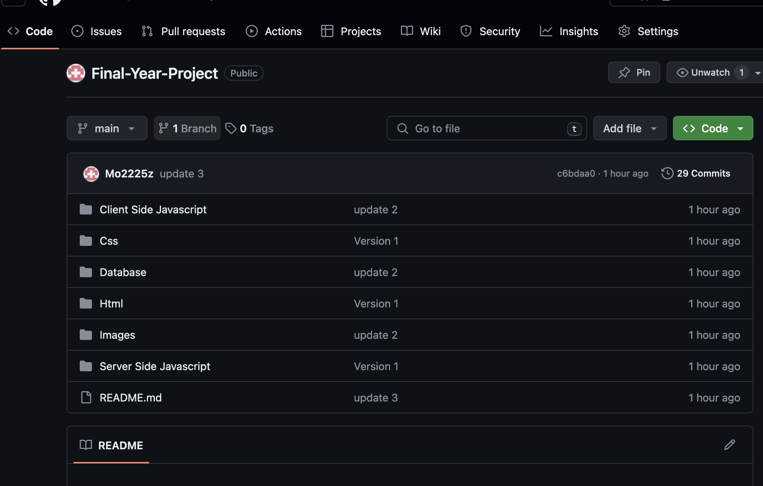

Figure 21. SHOWS INITIAL GITHUB REPOSITORY.

**Node modules:** I organized the backend code into different Node.js modules, each corresponding to specific functionalities of the application's web pages. This modularization approach ensured a clean and efficient architecture by encapsulating distinct functionalities within separate files [19].

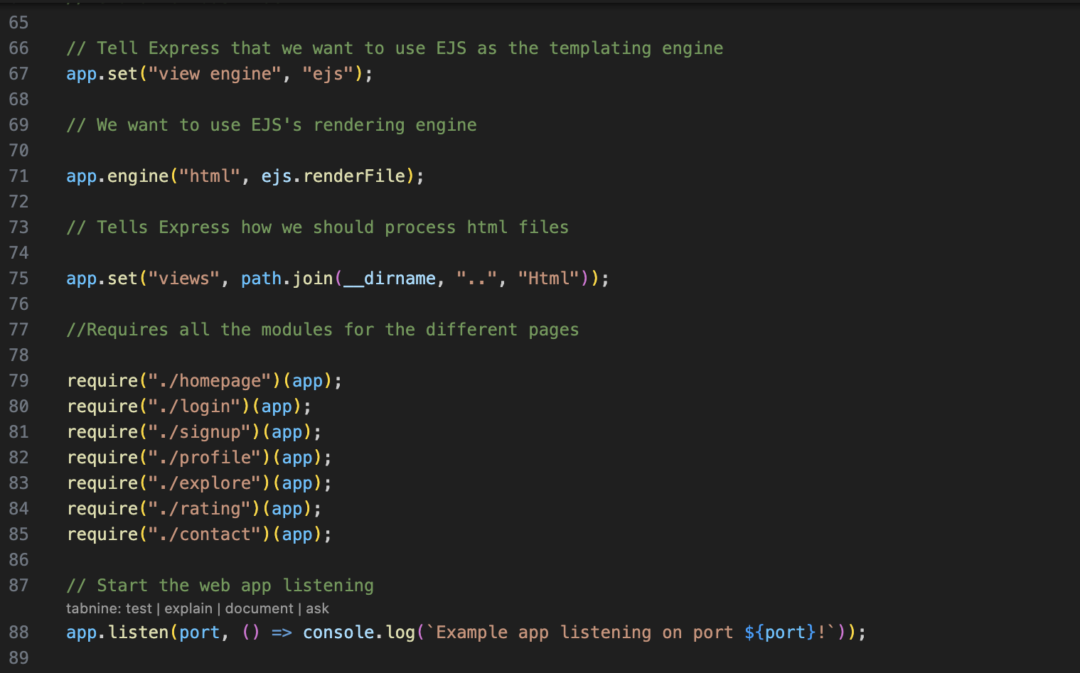

Figure 22. Showcases the different modules.

**Libraries installed:**

Several external modules were installed via Node.js's package manager using npm. These include essential libraries such as Express for server-side routing, EJS for templating, and MySQL for database interactions. Security-oriented modules like Bcrypt for hashing and securing passwords and 'dotenv' for managing environment variables were also integrated.

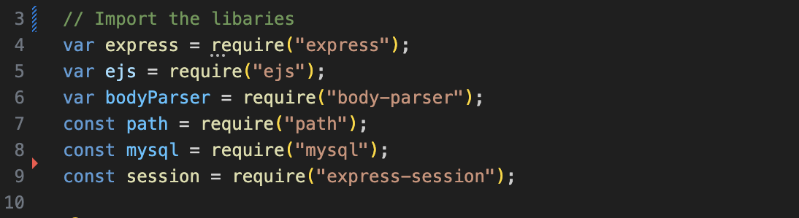

Figure 23. Showcases imported Libraries.

Table below shows the list of routes that will be required for the application to function.

| **Route** | **Method** | **Purpose** | **Authorization** | **Validation** |
| --- | --- | --- | --- | --- |
| / | GET | Home/landing page |  |  |
| /profile | GET | User profile | Signed in users only |  |
| /login | GET | Login form | Signed out users only |  |
| /login | POST | Login form handler | Signed out users only | Username: present, Password: present |
| /signup | GET | Register form | Signed out users only |  |
| /signup | POST | Register form handler | Signed out users only | Username: not taken, Password: valid format |
| /logout | GET | Logout user | Signed in users only |  |
| /contact | GET | Contact form |  |  |
| /explore | GET | Explore page |  |  |
| /rate | POST | Rating form handler | Signed in users only | Rating: valid range |

## **T**ools Used

The implementation of the web application was done by using the following tools:

**Node.js**: Served as the runtime environment for my application, handling server-side logic.

**Express.js**: A web application framework for Node.js for routing and middleware functionalities.

**EJS (Embedded JavaScript Templating):** I used it to generate HTML templates with embedded JavaScript, simplifying the creation of dynamic web pages.

**CSS:** I used it to style the application's front end, ensuring the web pages are visually appealing and functional.

**Bootstrap**: I used this front-end framework to design responsive web pages. It includes various ready-to-use components that enhance UI design and user experience.

**JavaScript**: The primary scripting language for both client-side and server-side development.

## Iteration and improvements

**Front-End improvements:** In response to user feedback, front-end improvements to the web application included a revised colour scheme for better visual appeal and readability, alongside enlarged buttons to enhance usability and accessibility, particularly on mobile devices. You can find the survey conducted here (Link)

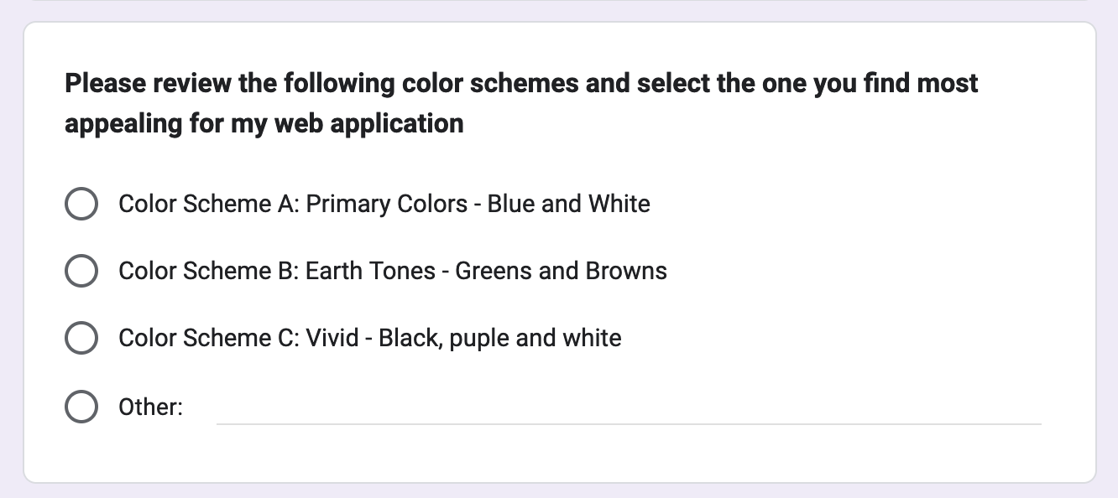

Figure 24. SHOWCASES SURVEY CONDUCTED ON DESIGN CHOICES.

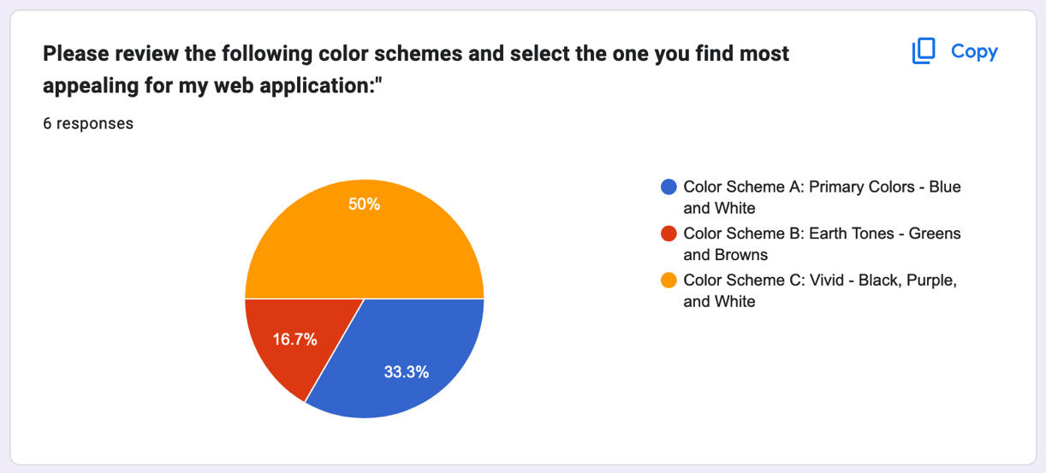

Figure 25. Showcases design survey results.

**Backend improvements**: Backend changes involved a shift from NoSQL to MySQL for the database system. I decided to do this because of the anticipated low volume of data, which MySQL handles more efficiently. Additionally, MySQL provides robust relational data integrity and supports complex queries.

**Rating system changes:** After user feedback that the old 5-star system was too simple, I upgraded it to encompass various evaluation aspects. The altered system now enables people to assess competency, likability, and influence on 4 options namely: very, yes, somewhat and no. This methodology is like what Photo Feeler employs to offer intricate resonance between the feedback given by users as well as their engagement patterns on this site.

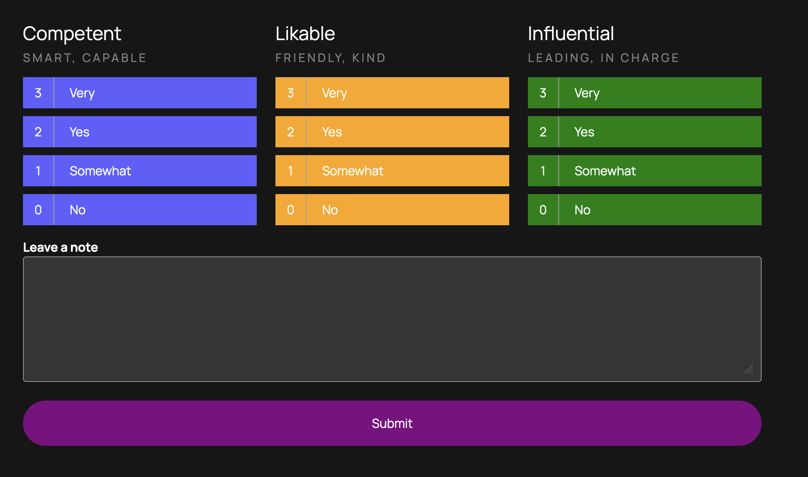

Figure 26. Showcases updated Rating system.

## Database Design & Configuration

**Database Structure Overview:** The database is structured in MySQL, creates a normalized design to minimize redundancy and ensure data integrity. My design comprises of two primary entities, users, and ratings. My setup begins by setting the SQL mode and transaction properties.

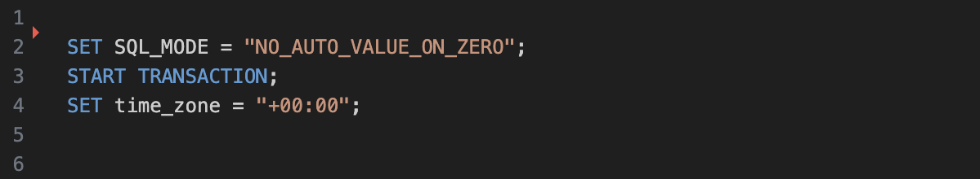

Figure 27. Showcases transaction setup.

**Users Entity:**

The user's table is designed to store user account information. Each record in the table represents a unique user, identified by an auto-incrementing primary key (id). The table includes:

* Fields for storing the user's full name (full_name).
* Email address (email).
* Profile picture URL (profile).
* Hashed password (password).

The email field is also indexed with a unique constraint to ensure no two users can register with the same email address. This table is fundamental for user authentication and profile management functionalities within the application.

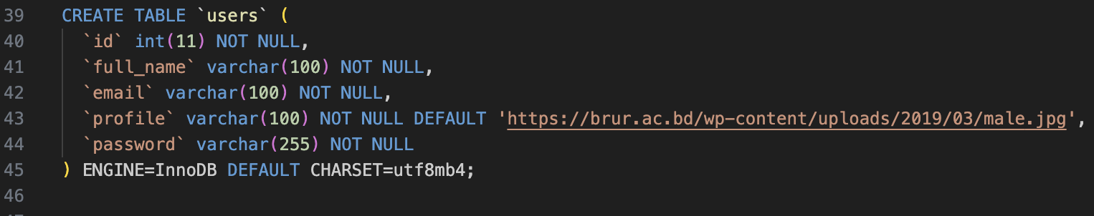

Figure 28. Showcases User Table.

**Ratings Entity:**

In the ratings table, comments left by users for each other are recorded. This table has the user (the rated user's ID), rated by (the rater's user ID), and an auto-incrementing ID as the primary key for every rating instance. The ID of the user table was linked to both foreign keys. Such an arrangement ensures relational integrity in my web app. Ratings can be categorized using three different attributes:

competent_rating, likable_rating, and influential_rating, each restricted to store integers. A text field called comment permits users to give textual feedback. The time field automatically captures the timestamp of when the rating was made and provides chronological context to this input.

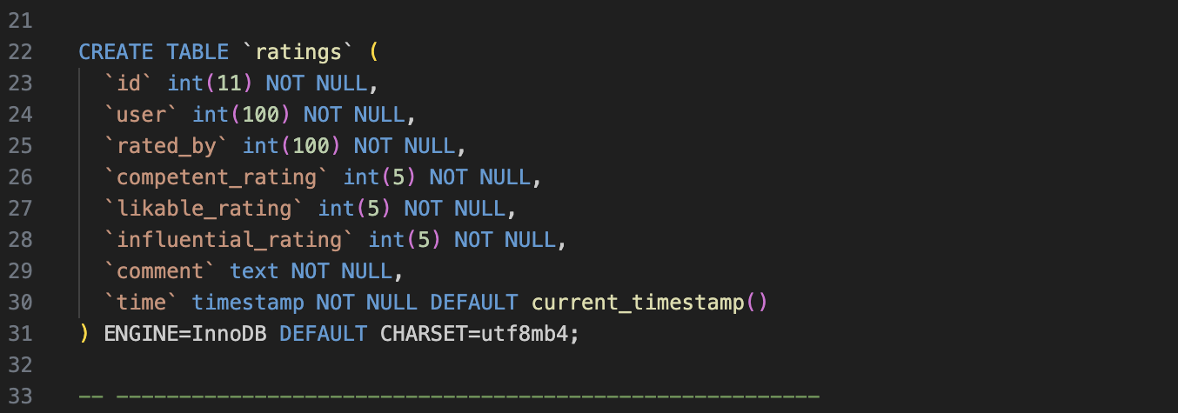

Figure 29. Showcases Rating table.

## **Business Rules/Algorithm**

**Overview of Rating Algorithm:** The Rate-me web application's algorithm determines average user ratings based on three factors: influence, likability, and competence. By giving their assessments more weight, my algorithm gives preference to users who have higher ratings, thereby recognizing their greater standing or reliability in the rating system. It was modified for this project using the Bayesian Algorithm [16] during its construction.

**Implementation of the Bayesian Algorithm:**

In my project "Rate-Me," I integrated the Bayesian Algorithm to refine how user ratings are calculated. This algorithm adjusts individual user ratings by considering both the global average rating and the number of ratings each user has received. Essentially, it moderates the impact of extreme ratings for users with fewer reviews by blending their scores with the overall average. This method is particularly beneficial in preventing new users from being unfairly disadvantaged by a small number of potentially biased ratings.

**Algorithm Explanation:** The weighted averages for the three rating categories are calculated by the getAverageRatings function. By multiplying each rating by ten and dividing the result by three, a weight is assigned to each rating. This process naturally scales and modifies the impact of each rating according to the strength of its corresponding attribute. Next, the outcomes are averaged across all ratings:

* **Competence:** This is calculated by summing the adjusted competence ratings of all reviews for a user and dividing by the number of ratings.
* **Likability:** Competence, the likability score is grouped by summing the adjusted values and then averaging them.
* **Influence:** The influence score is computed by accumulating the weighted influence ratings and averaging them.

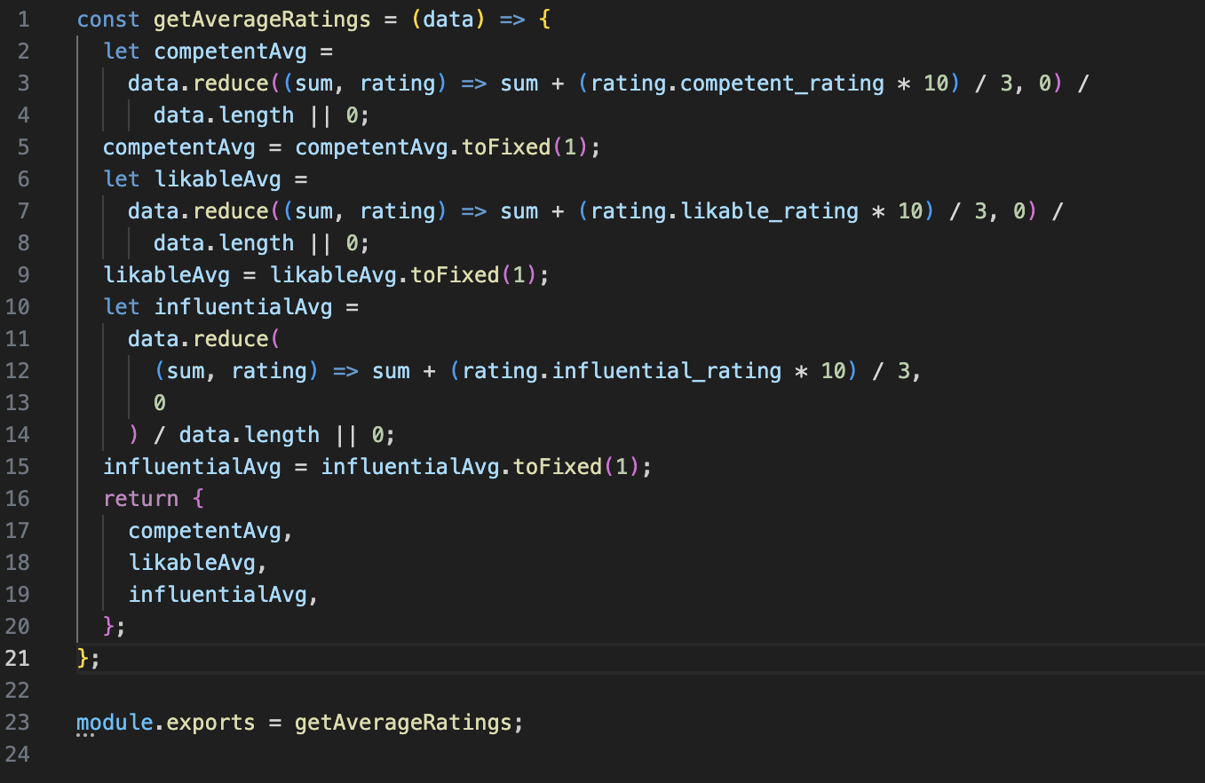

Figure 30. Shows Rating Algorithm.

**Time Complexity Analysis:** The getAverageRatings function has an O(n) time complexity, where n is the number of ratings. All ratings are processed in a single iteration through the array, and each rating takes a fixed amount of time to process.

**Influence on Community Dynamics**: The way in which the algorithm assigns greater weight to user ratings has a significant impact on the social dynamics of my web application. Through a positive feedback loop that increases the influence of highly rated users. This could lead to a stratification within the user base, making it harder for new or inactive users to change their reputation or visibility. I implemented a decaying influence algorithm [20] which ensures that newer interactions have more significance than older ones. This addresses the possibility of stratification within the "Rate-me" application.

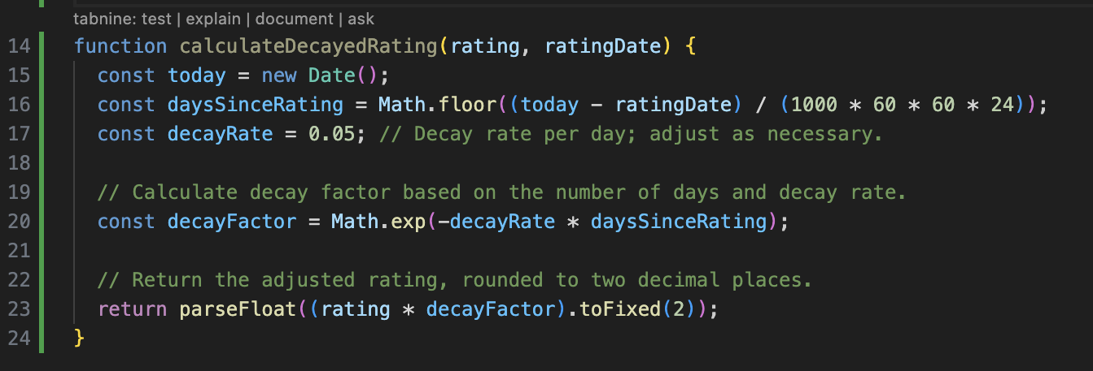

Figure 31. Showcases Decaying Algorithm.

### Example of the Bayesian Average in "Rate-Me"

In my project "Rate-Me," I chose to implement the Bayesian Average algorithm to provide a more stabilized and representative rating for users, especially those with few reviews. Here's how it functions in practice: Imagine the overall average rating across the application is 3.0, and the standard confidence level (reflecting an expected number of ratings) s 5. Let's consider a new user, Timmy, who has received three ratings: 5, 2, and 3. To compute Timmy’s Bayesian adjusted rating, we use the following formula:

Bayesian Average = (5×3.0)+(5+2+3)5+3=3.25

This calculation balances Timmy’s individual ratings with the broader average. My approach tempers the potential volatility of Timmy's initial high and low scores by weighting them against the more stable, community-wide average, thereby mitigating any extreme effects from a small sample size.

### Comparison of User Ratings

In my web application I use two main methods to compare user ratings. The getAverageRatings function normalizes ratings by scaling each for competence, likability, and influence, providing balanced metrics across different user attributes. Additionally, I employ a weighted system where more active and credible users have their ratings emphasized, ensuring that experienced community members have a greater impact on overall ratings.

**Example Scenario:**

**User A**: Highly active, frequently rates other users, and has a history of consistent participation.

**User B**: Relatively inactive, barely participates in rating others.

**Impact of Ratings:**

**When User A Rates**:

**High Influence**: Since User A is highly active and has built credibility within the application, their ratings carry more weight. If User A gives a high rating to another user, it significantly impacts the recipient's overall rating. Conversely, a low rating from User A could considerably lower another user's score.

**When User B Rates**:

**Lower Influence**: User B's ratings have less impact due to their limited activity and lower credibility on the platform. Whether User B's ratings are high or low, they influence the overall scores to a lesser extent compared to those from more active users like User A.

## Features

### Index.js

**Purpose and Interactions**: index.js is the central configuration file, setting up the server, database connections and middleware.

* **Server and Database Setup**: Created the Express server that connects to my MySQL database which manages application data.
* **Middleware Integration**: Configured body parser for form data handling and session middleware for user session management.
* **Modules Setup**: The different modules for each page are initialised.

**Key Features:**

* Express server initialization
* Middleware configuration for body parsing and session management
* Route definitions and management

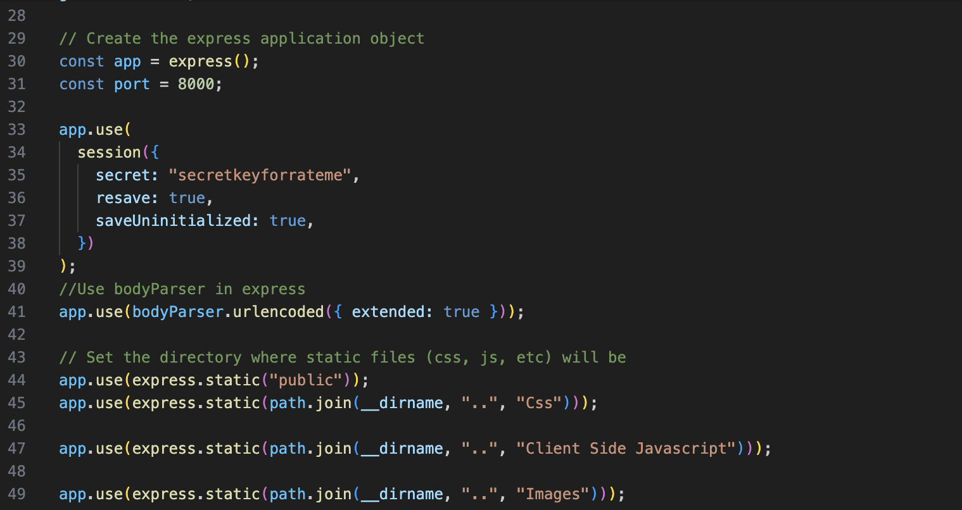

Figure 32. Shows Express and Body parser setup.

### Homepage.js

**Purpose and Interactions:** homepage.js manages the main landing page of the Rate-me application. It dynamically renders content based on whether the user is logged in or not. For logged-in users, it redirects them to their profile page. For visitors, it displays top users based on their ratings.

**Detailed Functionality:**

* **User Redirection:** It will redirect logged-in users to their profile page by providing direct access to personal content.
* **Database Query Execution:** For visitors, it executes a SQL query to retrieve all users from the database. For logged-in users, it fetches all other users except the logged-in user.
* **Dynamic Content Rendering:** After fetching user data, it calculates average ratings for each user and displays a sorted list of top users based on their ratings.
* **Weather API:** Show the current temperature based on the country that the user initially selected when signing up.

**Key Features:**

**Dynamic SQL Querying:** Depending on the user’s session status, it tailors SQL queries to fetch appropriate user data.



Figure 33. Showcases fetching user data.

**Weather API:** Depending on country status the weather API will fetch the appropriate data to display on the homepage.

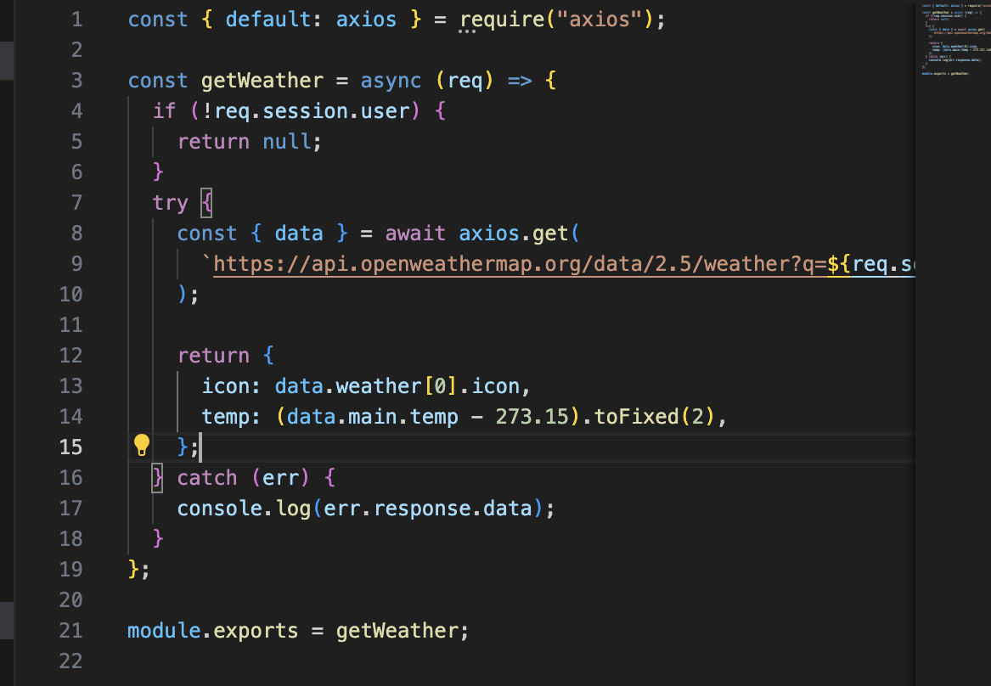

Figure 34. Showcases weather API FETCHING.

**Top Users Display:** Sorts users by the number of ratings and their average ratings, then selects the top four to display on the homepage.

### Explore.js

**Purpose and Interactions:** Explore.js this feature creates user exploration of other profiles within the Rate-me application, allowing users to search, filter, and view profiles based on specific criteria. My web application provides dynamically filtered results and redirects non-authenticated users to the login page.

**Detailed Functionality:**

* **Authentication Check:** Redirects non-authenticated users to the login page, making sure that only logged-in users can explore other profiles.
* **Dynamic SQL Querying:** Executes a SQL query to fetch all users except the logged-in user.
* **Search and Filter:** Functionality to filter the results based on a search query entered by the user.
* **Advance Filters: Users can filter based on country and profession to find like-minded individuals.**

**Key Features:**

**User Filtering Logic:** Implements logic to filter users dynamically based on user input from a search bar. This allows users to find profiles by names that contain the typed query.

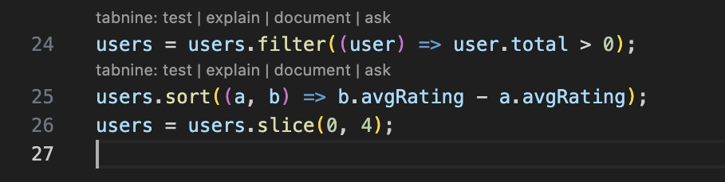

Figure 35. Showcases top user’s filter.

**Average Rating Calculation and Sorting:** After fetching ratings for each user, it calculates average ratings and sorts users based on the specified sort criteria ('suggested' or 'featured').

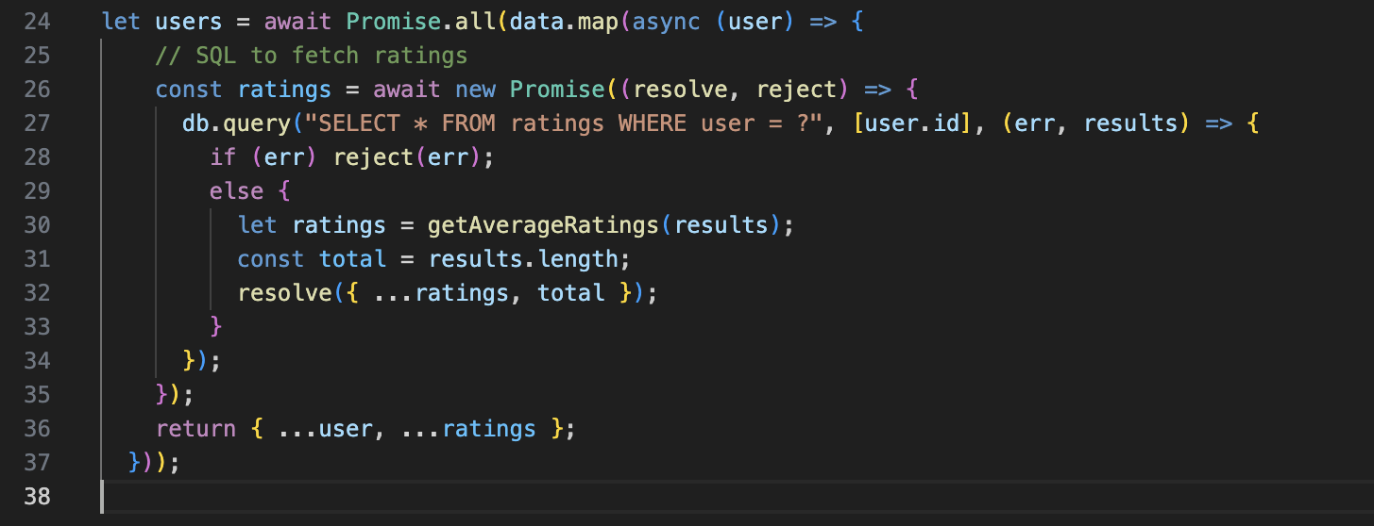

Figure 36. Showcases rating calc code.

### Rating.js

**Purpose and Interactions:** rating.js manages the rating interactions within the Rate-me application, allowing users to rate other users based on different criteria. This file handles both the display of user ratings and the submission of new ratings.

**Detailed Functionality:**

* **Rating Display:** When a user navigates to the rating page, the application fetches existing ratings for a specific user from the database. It displays these ratings, or a default message if no ratings exist.
* **Rating Submission:** Allows logged-in users to submit ratings for other users, capturing several aspects of user performance such as competence, likability, and influence.

**Key Features:**

**User Authentication and Redirection:** Redirects non-authenticated users to the login page, ensuring that only logged-in users can access the rating functionalities.

**SQL Query for User Ratings:** Executes a SQL query to fetch the user details along with their ratings. If ratings exist, it calculates average ratings; if not, it initializes average ratings to zero.

**Handling Rating Submissions:** Processes POST requests for new ratings, inserting them into the database and then redirecting the user back to the explore page.

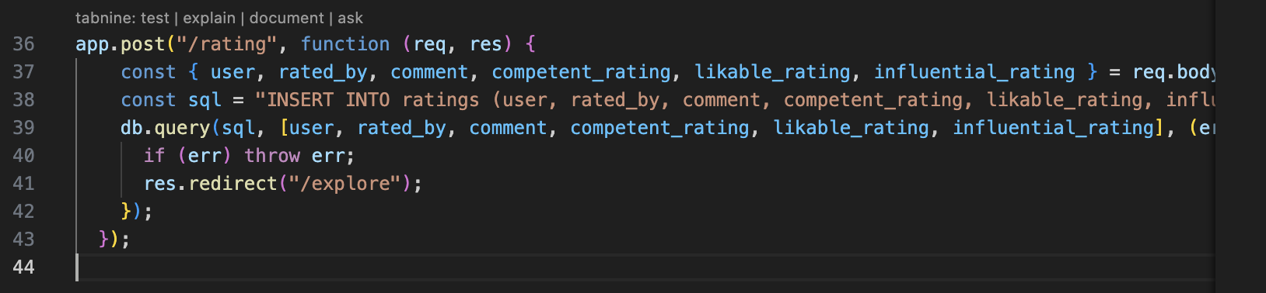

Figure 37. Showcasing post request for rating submissions.

### Profile.js

**Purpose and Interactions:** profile.js handles user profile interactions within the Rate-me application, focusing on displaying user ratings and managing profile updates.

**Detailed Functionality:**

* **Profile Display:** When a user accesses their profile, the application queries the database for their ratings calculating average ratings if any exist. If no ratings are found it displays the default values.
* **Profile Update:** Functionality for users to update their profile picture using Multer middleware, which handles file uploads securely.
* **Categories: User selection of country and profession when signing will be displayed on the profile.**
* **Ratings:** Users will be able to see who rated them below their profiles.
* **Update profile:** Users can update their profiles to include their Facebook and LinkedIn accounts.

**Key features:**

**Authentication Check and Redirection:** Redirects non-authenticated users to the login page.

**SQL Query for User Ratings:** Executes a SQL query to fetch the user's ratings and calculates an average based on the competent, likable, and influential scores.

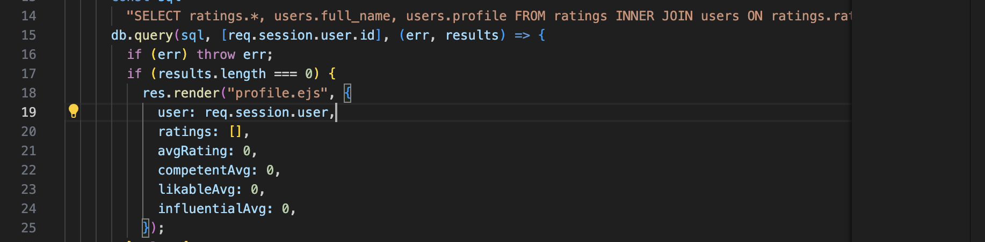

Figure 38. Fetching User ratings data showcase.

### **Login.js**

**Purpose and Interactions:** login.js manages user authentication within my web application, securely verifying user credentials and handling user sessions.

**Detailed Functionality:**

* **Login Page Rendering:** Displays the login page, redirecting already logged-in users directly to their profile, enhancing user flow and security.
* **User Authentication:** Validates user credentials against stored data in the database and handles session setup upon successful login.

**Key Features:**

**Session Management and Redirection:** Checks if a user is already logged in; if so, redirects to the profile page to avoid redundant login attempt.

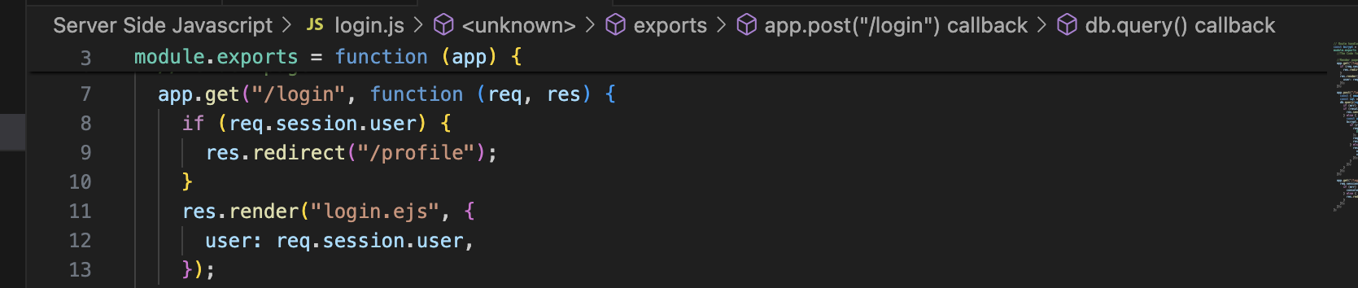

Figure 39. REDIRECTION SHOWCASE.

**Credential Verification:** Verifies email and password during the login process. It uses bcrypt to safely compare the provided password with the hashed password stored in the database.

## Application screenshots

The below figures show the key components of the application:

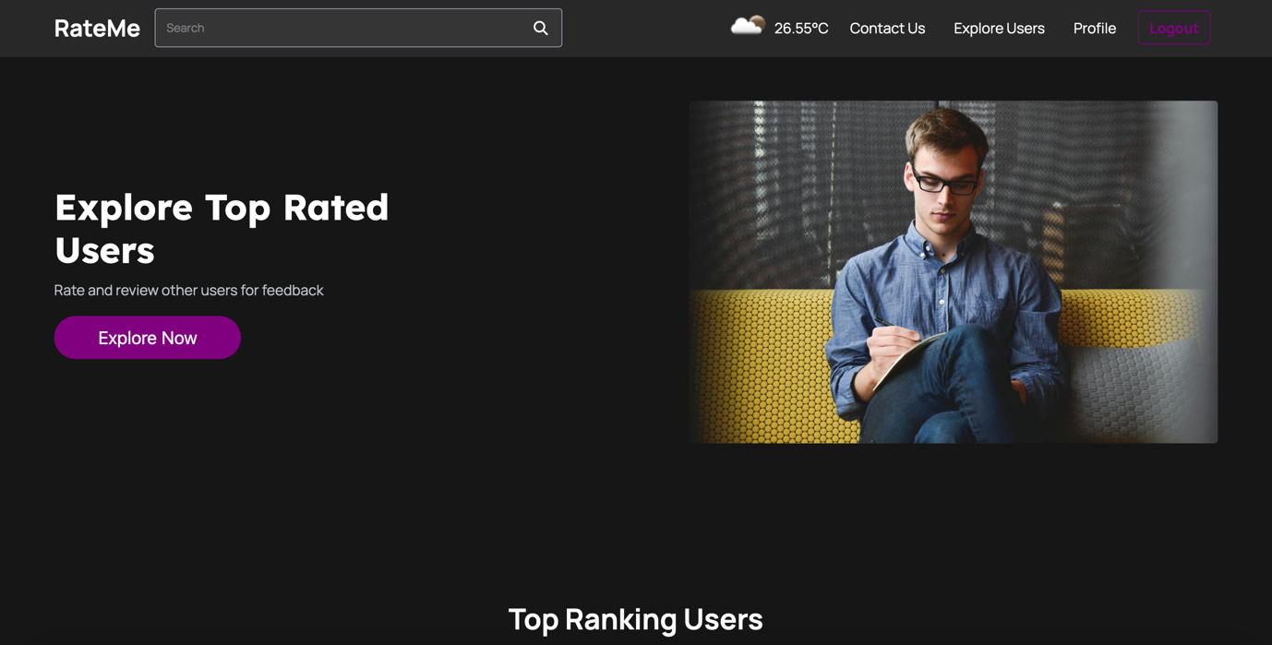

Figure 40. Homepage Screenshot of Web application.

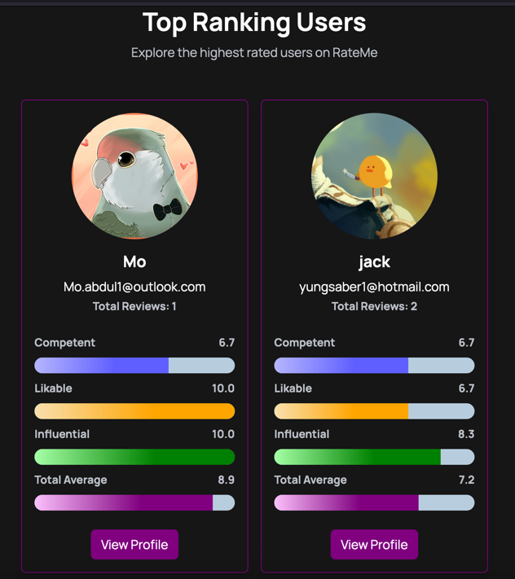

Figure 41. Showcases top ranking users table.

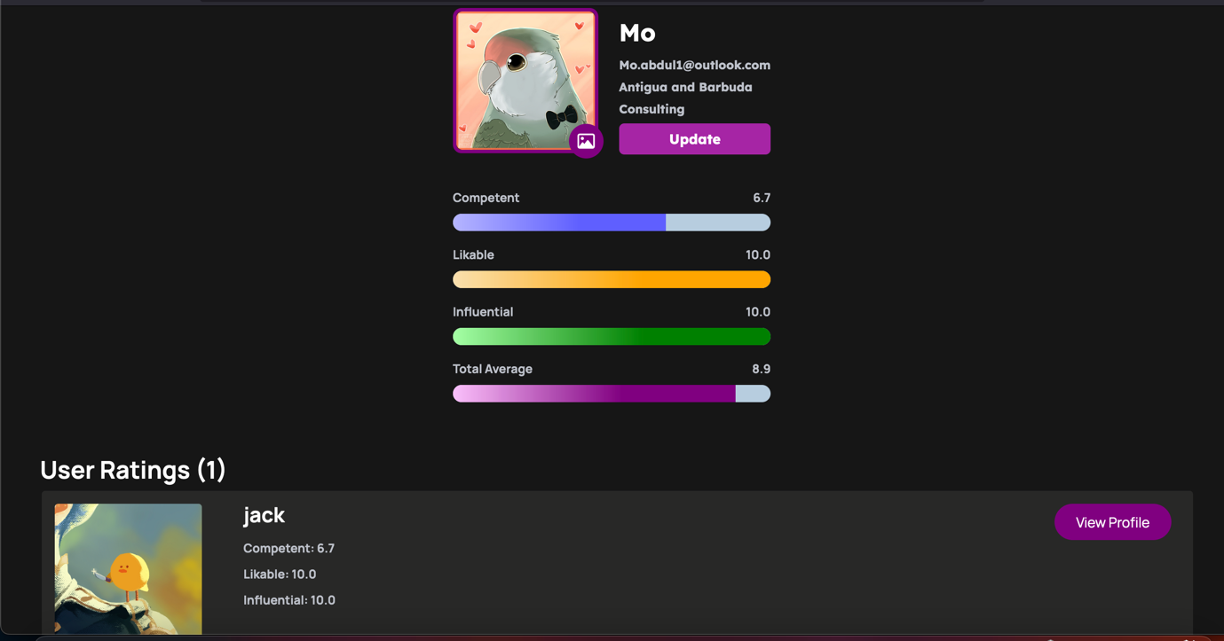

Figure 42. Showcases profile page.

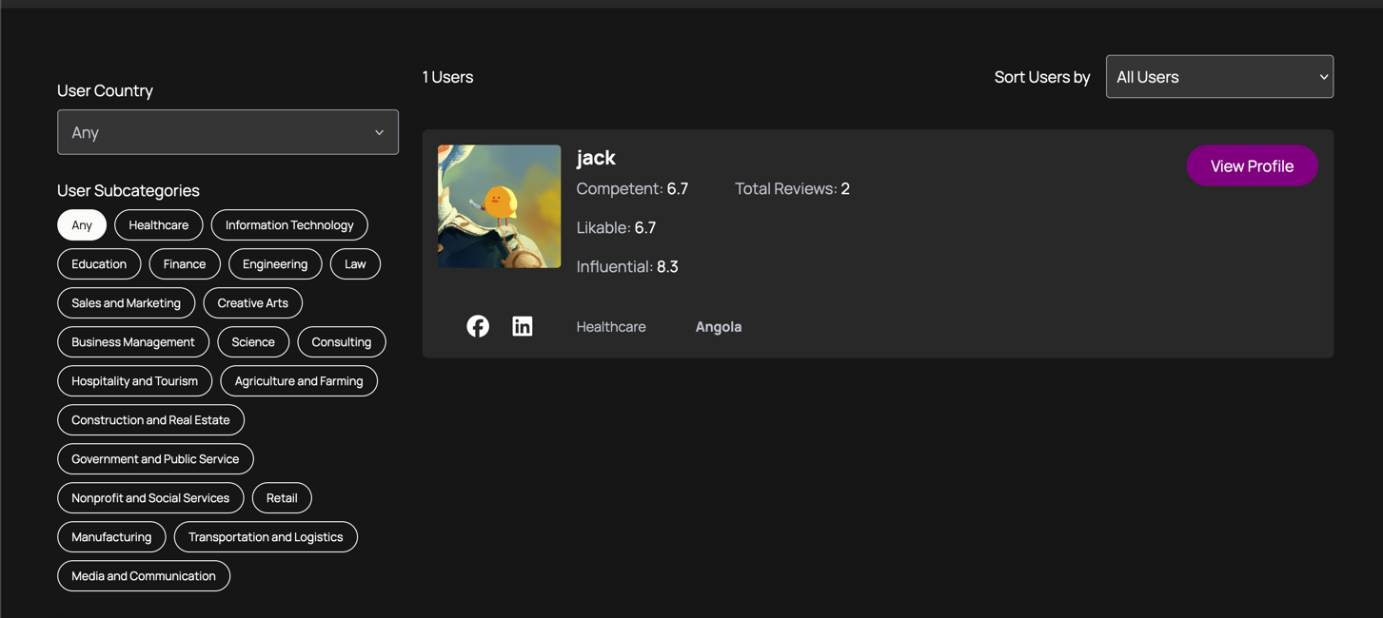

Figure 43. Showcases explore page.

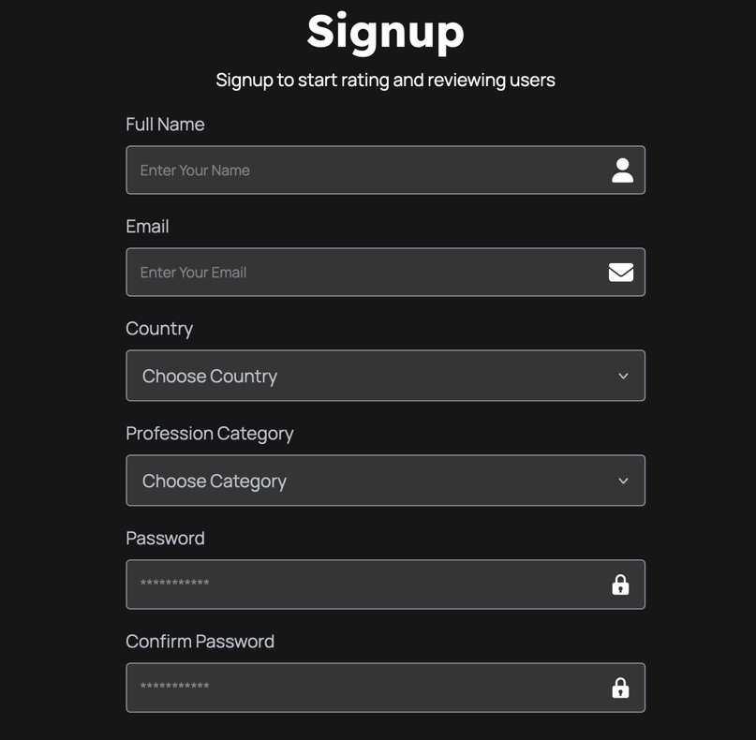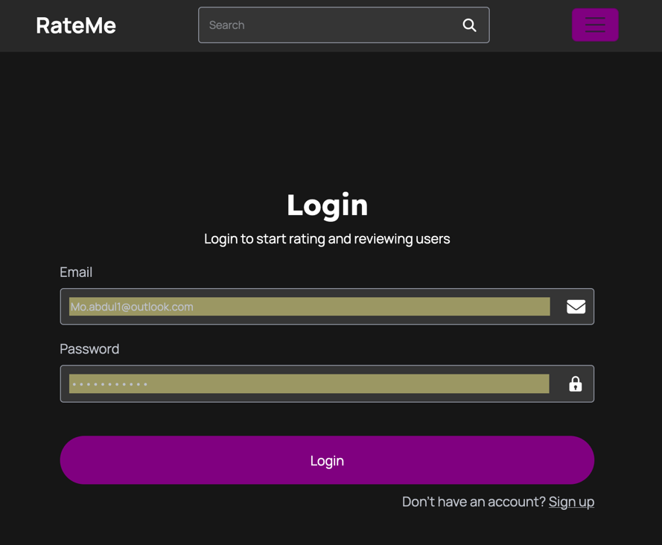

Figure 44. Showcases login page.

Figure 45. Showcases sign up page.

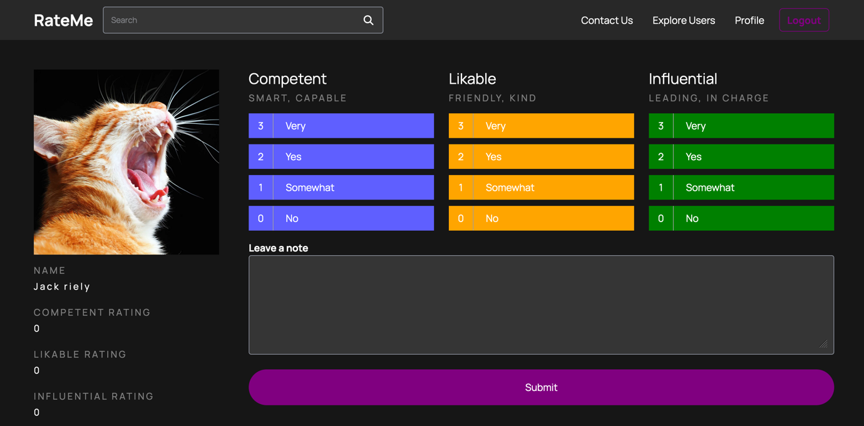

Figure 46. Showcases user rating system.

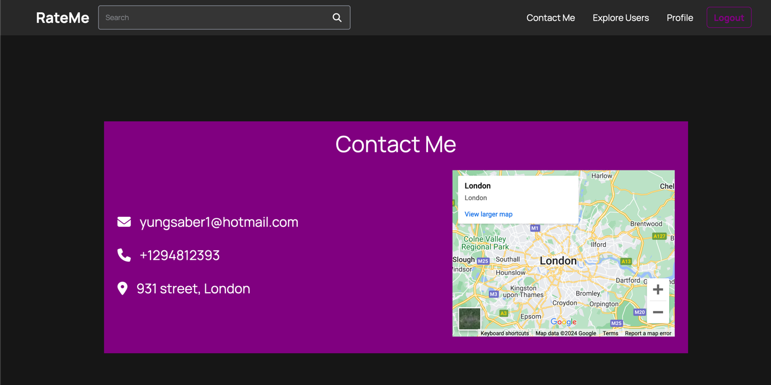

Figure 47. Showcases the contact page.

## Testing

Three tests will be completed to test the functionalities of Rate-me thoroughly: White Box testing, Black Box testing, and User testing. It is worth noting that this project was completed using an Agile methodology, Test-Driven Development (TDD) [17]. This involved testing every function as it was created and remediating any issues identified.

### Whitebox testing

White Box testing confirms that the internal structure and functionalities are working as expected [21]. The testing was completed by a software developer who understands the code. The table below shows the main functionalities of the Rate-me web application and the results of White Box testing (creating various use cases that relate to different parts of the app to ensure they all work correctly). The table can be viewed on (Link)

### Blackbox testing

Black-Box testing is performed after the application has been developed, compared to White-Box testing during development. Black-Box is used to test that the application works as expected but not by testing the internal component [22]. Below you will find the table of tests conducted. The table can be viewed on (Link)

### User Testing

User Testing was also used as it is essential to gain feedback from individuals, and any improvements (such as design or extra features) would be considered in future releases of this app. User testing can also provide valuable results about the usability of the app and system acceptance (as users can state afterward whether they had an issue using the app).

The individuals were briefed on the application but were not given any instructions or walkthroughs; this would help test whether the app was intuitive and whether the usability was acceptable (as the individuals would be asked questions regarding the app's navigation). The individuals were given 30 minutes to use the app and then provide feedback via an online anonymous survey (rather than face-to-face, to ensure that results were more reliable as individuals may not give accurate opinions in person). The complete survey can be found in (Link). The results are shown below:

**Question 1:**

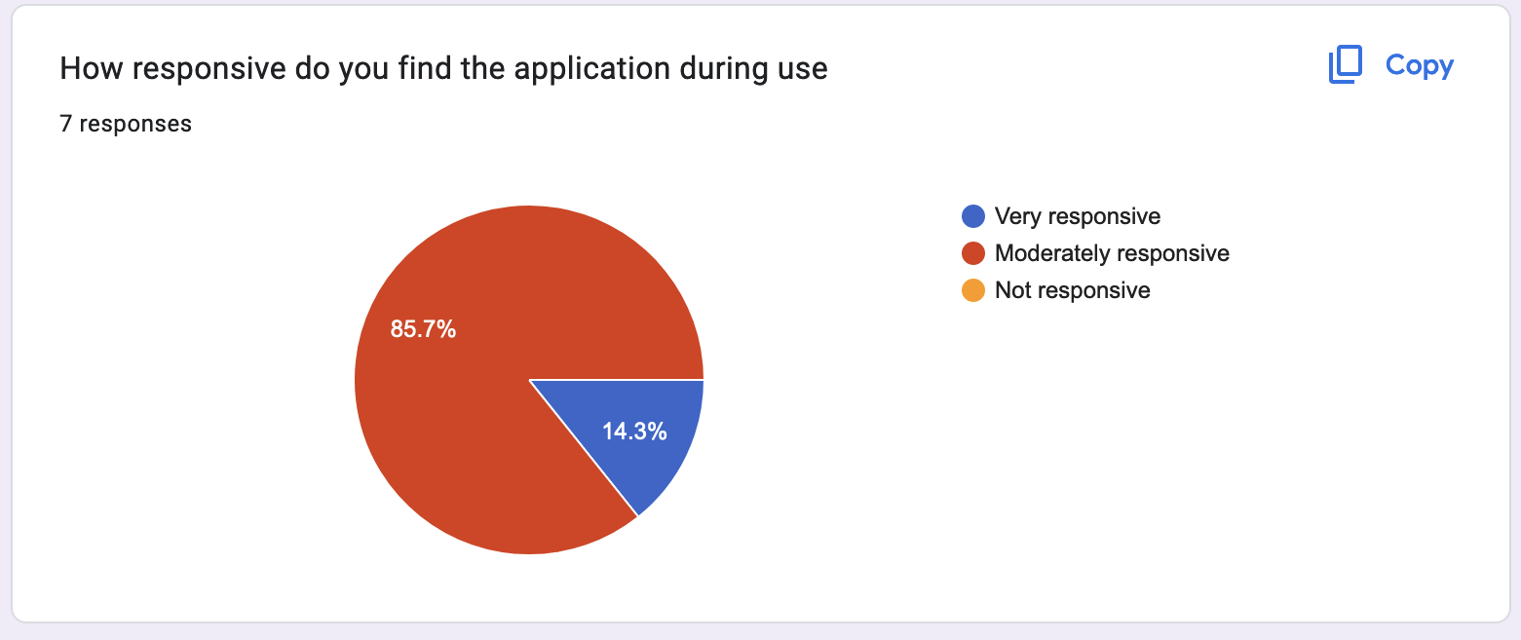

Figure 48. How responsive was the app?

**Questions 2:**

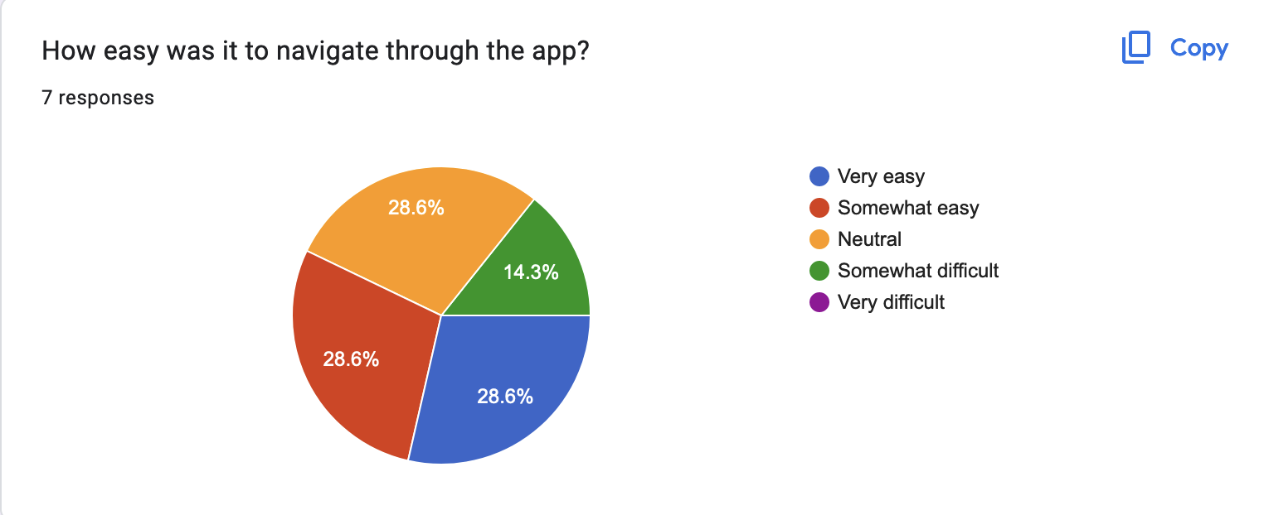

Figure 49. HOW EASY WAS IT TO NAVIGATE THROUGH THE APP?

Question 3:

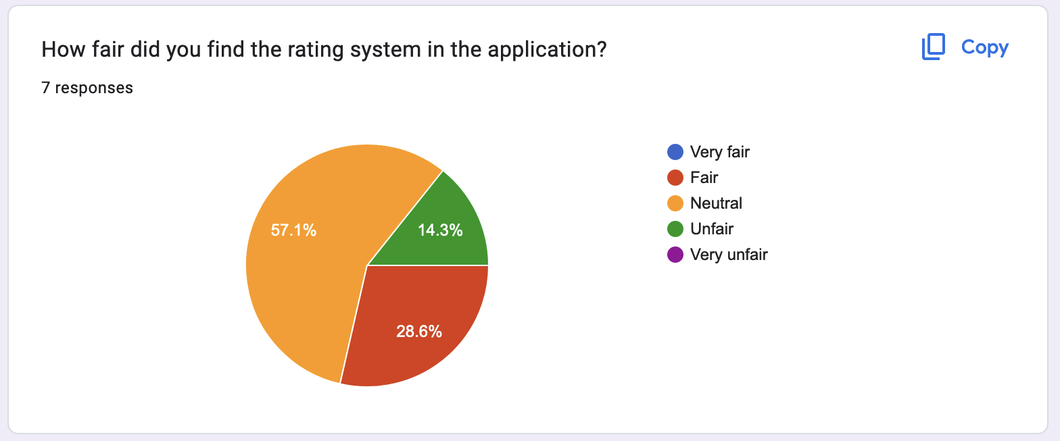

Figure 50. HOW FAIR DID YOU FIND THE RATING SYSTEM?

## Evaluation

### Psychological perspective

In my evaluation of "Rate-Me" from a psychological perspective, I observed significant implications on user behaviour and emotional well-being. The application's reliance on a public rating system elicited a spectrum of responses, reflecting its impact on users' social self-esteem and interactions. I’ve gathered quotes from the users who tested my application which you will find in the table below:

| **Response Type** | **Psychological Impact** | **Direct Quotes** |
| --- | --- | --- |
| **Positive** | Increased self-esteem and social validation | "Getting a high rating made me feel really good about myself and validated." |
|  | Boosted confidence | "Seeing that others rated me highly boosted my confidence a lot." |
| **Neutral** | Curiosity and reflective thinking | "It's interesting to see how others view me, though it can feel a bit exposing." |
|  | Insight into self-perception | "I find it fascinating to know how people perceive me." |
| **Negative** | Decreased self-esteem and increased anxiety | "Receiving a low rating was pretty tough; it made me doubt myself." |
|  | Discomfort and self-doubt | "I like the honesty, but negative feedback can be hard to take." |

The data reveals that while positive feedback can enhance self-esteem and confidence, negative feedback can significantly harm emotional well-being, leading to anxiety and self-doubt. These reactions highlight the importance of ethical considerations in designing such systems. I need to ensure that feedback mechanisms are constructive and not overly harsh to help mitigate negative psychological impacts. Additionally, offering support resources for users who may be adversely affected by ratings could be a valuable enhancement to any future iterations of my application.

### Challenges

**Scheduling and Project Management:**

One of the primary challenges I encountered during the development of the web application was managing the project timeline effectively. Balancing the demands of the project with academic responsibilities and personal commitments proved to be particularly taxing. The iterative nature of the development process, including time allocated for planning, designing, coding, testing, and revising, often conflicted with other obligations. This misalignment sometimes led to rushed sessions and extended work hours, impacting both the project's progress and my personal well-being.

**Ensuring Fairness in the Rating System:**

Creating a fair and unbiased rating system presented a considerable challenge. The initial model tended to favour users who were early participants in the platform, skewing the ratings disproportionately. Adjusting the algorithm to weight ratings based on a variety of factors—such as the number of ratings, the recency of feedback, and the diversity of raters—required careful thought and multiple iterations. This adjustment aimed to produce a more balanced and equitable system, where all users, regardless of when they joined, had a fair representation in the ratings.

### Analysis of Racial Bias in Ratings

Implicit biases and societal stereotypes have a recurrent theme in my project on why racial minorities frequently receive lower ratings in social experiments. The statistical foundations of these discrepancies imply that these biases may be subtly influencing assessments, resulting in minorities consistently receiving lower scores than Caucasians, even in situations where their performances are equivalent. [23]

As the user testing was conducted, a pattern emerged of minorities being rated lower. There is an apparent statistical element missing that needs further investigation. Since I haven’t captured it in this report due to time restrictions, I will do further investigations to correct this issue in the future.

### Limitations

**Scalability Concerns**

One of the inherent limitations of the current implementation of the web application is its scalability. While the application performs adequately under the current user load, the backend architecture and database design may not effectively handle a significant increase in user numbers or data volume. This limitation is partly due to the simplistic query structures and the lack of distributed database solutions, which could impede performance as the system scales.

**Scalability testing:**

I implemented a systematic increase in virtual user load through automated scripts. These scripts simulated typical user behaviours, stressing both the front end and database operations to assess the application’s ability to handle concurrent users. By incrementally raising the number of users, I observed response times and system stability to identify any performance bottleneck. You will find the results here (link)

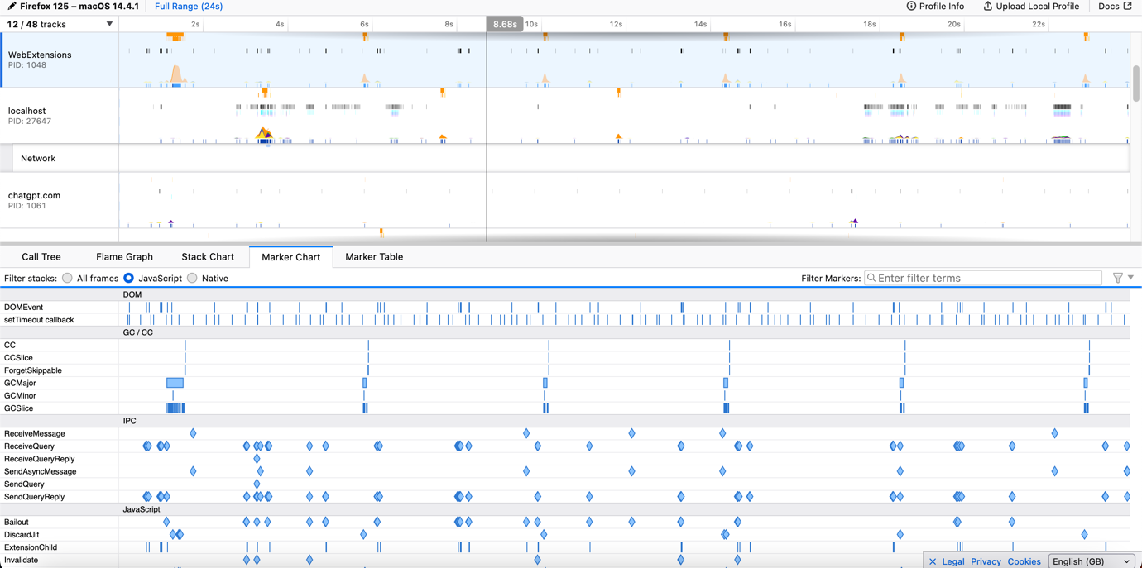

Figure 51. Showcases database testing.

**Real-Time Data Processing:**

Currently, the application does not support real-time data processing, which limits the interaction dynamics of the web. Particularly in features like live ratings or updates. Users must manually refresh pages to see updated data, which can detract from the user experience and decrease the system's efficiency and appeal in scenarios where real-time feedback is crucial.

### Project outcomes

**Result Analysis:**

The final iteration of my web application notably advanced from the initial concept in terms of functionality and user interaction. Provides an integrated profile management, rating systems, and advanced search features, the application met the fundamental objectives set at the project's outset. However, while the core functionalities were implemented as planned, certain advanced features like real-time notifications and a fully adaptive user interface were deferred for future updates due to time constraints.

**Aims and Objectives Fulfilment:**

My project successfully achieved its primary aims, including creating a secure, user-friendly platform where users could interact, rate each other and update profiles. The integration of third-party libraries for features like password hashing and image uploading enhanced the application’s security and usability. My project still has room to grow given only the MVP was met. Other enhancements are planned for future iterations of the application.

### Personal reflection

**Development Methodology Efficacy:**

The iterative development approach adopted for this project proved highly effective, allowing for continuous feedback and incremental improvements. Regular reviews and adaptations helped address issues promptly, though at times the pace felt rushed due to tight deadlines.

**Reflecting on Time Management:**

Managing the project timeline was a continual balancing act. While I met most deadlines, the experience underscored the importance of effective time management and its impact on project quality and stress levels.

### Future enhancements

**Adoption of NoSQL Databases:**

To better accommodate growing user volumes and the need for scalable, flexible data storage solutions, future developments will include transitioning to a NoSQL database. This shift will facilitate more efficient handling of large data sets and unstructured data.

I anticipate handling unstructured data such as user comments and feedback, which are varied in format and content. If the popularity of the application grows then I expect a substantial increase in the number of ratings. This expansion will challenge the current database infrastructure because it’s far more difficult to query and analysis large data in my current setup. This will push me towards considering scalable solutions like NoSQL database structures which are primarily used for social media applications due to it being more scalable.

**Improved Time Management Techniques:**

Further enhancements will focus on refining project management and scheduling techniques. Adopting proven strategies such as the Pomodoro Technique will enhance productivity and efficiency, ensuring timely delivery of updates and maintenance, while also mitigating the stress associated with tight deadlines.

### Demonstration video

Link: <https://goldsmithscollege-my.sharepoint.com/:v:/g/personal/mahme003_campus_goldsmiths_ac_uk/Ed2OypIeZlFEpv213MC2goYBKqxHBi13B-uxtSp5OCz_UA?referrer=Teams.TEAMS-ELECTRON&referrerScenario=MeetingChicletGetLink.view.view>

# Conclusion

In my project "Rate-Me," I set out to change how we see and interact on social media by letting users rate each other through a social experiment. This isn’t just another app; it’s about digging deeper into how we view each other’s social standing. Using Node.js and MySQL with my rating algorithm, I've tried to make the process fair though there are still improvements to be made due to the bias inherent in people when it comes to rating others. The feedback I received was incredibly valuable, pushing me to make iterative improvements. Looking ahead, I’m excited to tackle some bigger challenges like improving the app’s ability to handle more users at once and updating data in real time. There's more work left to do, but I’m ready for it.

# References

[1] C. Brinkhurst-Cuff, ‘What it’s like for ethnic minorities dating online’, BBC Three. Accessed: May 15, 2024. [Online]. Available: https://www.bbc.co.uk/bbcthree/article/83fb8f3e-f1f6-4df9-ab5c-14e856ce486b

[2] C. Dellarocas, ‘The Digitization of Word of Mouth: Promise and Challenges of Online Feedback Mechanisms’, *Manag. Sci.*, vol. 49, May 2003, doi: 10.2139/ssrn.393042.

[3] L. Bornmann and H. Daniel, ‘What do citation counts measure? A review of studies on citing behavior’, *J. Doc.*, vol. 64, no. 1, pp. 45–80, Jan. 2008, doi: 10.1108/00220410810844150.

[4] S. Deterding, D. Dixon, R. Khaled, and L. Nacke, ‘From game design elements to gamefulness: defining “gamification”’, in *Proceedings of the 15th International Academic MindTrek Conference: Envisioning Future Media Environments*, Tampere Finland: ACM, Sep. 2011, pp. 9–15. doi: 10.1145/2181037.2181040.

[5] danah m. boyd and N. B. Ellison, ‘Social network sites: Definition, history, and scholarship’, *J. Comput.-Mediat. Commun.*, vol. 13, no. 1, pp. 210–230, 2007, doi: 10.1111/j.1083-6101.2007.00393.x.

[6] P. Resnick, R. Zeckhauser, J. Swanson, and K. Lockwood, ‘The value of reputation on eBay: A controlled experiment’, *Exp. Econ.*, vol. 9, no. 2, pp. 79–101, Jun. 2006, doi: 10.1007/s10683-006-4309-2.

[7] A. Nadkarni and S. G. Hofmann, ‘Why do people use Facebook?’, *Personal. Individ. Differ.*, vol. 52, no. 3, pp. 243–249, Feb. 2012, doi: 10.1016/j.paid.2011.11.007.

[8] S. Tadelis, ‘Reputation and Feedback Systems in Online Platform Markets’, *Annu. Rev. Econ.*, vol. 8, no. Volume 8, 2016, pp. 321–340, Oct. 2016, doi: 10.1146/annurev-economics-080315-015325.

[9] P. M. Valkenburg and J. Peter, ‘The Differential Susceptibility to Media Effects Model’, *J. Commun.*, vol. 63, no. 2, pp. 221–243, Apr. 2013, doi: 10.1111/jcom.12024.

[10] H. Postigo, ‘The socio-technical architecture of digital labor: Converting play into YouTube money’, *New Media Soc.*, vol. 18, no. 2, pp. 332–349, Feb. 2016, doi: 10.1177/1461444814541527.

[11] ⋅, 19 Min Read, 503 Shares, and 239k Reads, ‘The Top 10 Social Media Sites & Platforms’, Search Engine Journal. Accessed: May 13, 2024. [Online]. Available: https://www.searchenginejournal.com/social-media/social-media-platforms/

[12] ‘20 Social Media Platforms Ruling the World in 2024’. Accessed: May 13, 2024. [Online]. Available: https://www.socialchamp.io/blog/social-media-platforms/

[13] S. Sukparungsee, Y. Areepong, and R. Taboran, ‘Exponentially weighted moving average—Moving average charts for monitoring the process mean’, *PLOS ONE*, vol. 15, no. 2, p. e0228208, Feb. 2020, doi: 10.1371/journal.pone.0228208.

[14] D. G. de P. Zanco, L. Szczecinski, E. V. Kuhn, and R. Seara, ‘Stochastic analysis of the Elo rating algorithm in round-robin tournaments’, *Digit. Signal Process.*, vol. 145, p. 104313, Feb. 2024, doi: 10.1016/j.dsp.2023.104313.

[15] Y. Zhang and Y. Yang, ‘Bayesian model selection via mean-field variational approximation’, *J. R. Stat. Soc. Ser. B Stat. Methodol.*, p. qkad164, Apr. 2024, doi: 10.1093/jrsssb/qkad164.

[16] C. Banchhor and N. Srinivasu, ‘Analysis of Bayesian optimization algorithms for big data classification based on Map Reduce framework’, *J. Big Data*, vol. 8, no. 1, p. 81, Jun. 2021, doi: 10.1186/s40537-021-00464-4.

[17] ‘What is Test-Driven Development?’ Accessed: May 13, 2024. [Online]. Available: https://testdriven.io/test-driven-development/

[18] ‘What is GDPR, the EU’s new data protection law?’, GDPR.eu. Accessed: May 14, 2024. [Online]. Available: https://gdpr.eu/what-is-gdpr/

[19] A. Singh, ‘Code Like a Pro: The Benefits of Modular Coding in Data Science’, Medium. Accessed: Apr. 29, 2024. [Online]. Available: https://medium.com/@Ambarish_224/code-like-a-pro-the-benefits-of-modular-coding-in-data-science-5c00ae46be49

[20] N. Ohsaka, Y. Yamaguchi, N. Kakimura, and K. Kawarabayashi, ‘Maximizing Time-Decaying Influence in Social Networks’, in *Machine Learning and Knowledge Discovery in Databases*, P. Frasconi, N. Landwehr, G. Manco, and J. Vreeken, Eds., Cham: Springer International Publishing, 2016, pp. 132–147. doi: 10.1007/978-3-319-46128-1_9.

[21] ‘What Is White Box Testing | Types & Techniques for Code Coverage | Imperva’, Learning Center. Accessed: Apr. 29, 2024. [Online]. Available: https://www.imperva.com/learn/application-security/white-box-testing/

[22] ‘What is Black Box Testing | Techniques & Examples | Imperva’, Learning Center. Accessed: Apr. 29, 2024. [Online]. Available: https://www.imperva.com/learn/application-security/black-box-testing/

[23] K. Chávez and K. M. W. Mitchell, ‘Exploring Bias in Student Evaluations: Gender, Race, and Ethnicity’, *PS Polit. Sci. Polit.*, vol. 53, no. 2, pp. 270–274, Apr. 2020, doi: 10.1017/S1049096519001744.

# Appendix

## Table of figures

Figure 1. Showcases Main pages. 6

Figure 2. Showcases page sections in detail. 6

Figure 3. Showcases THE main MVPS. 6

Figure 4. Showcases kanban project management tool. 8

Figure 5. Showcases application cycle. 8

Figure 6. Showcases project plan. 10

Figure 7. Showcases user persona. 12

Figure 8. Showcases review/rating usecase. 21

Figure 9. Showcases search and discover use case. 22

Figure 10. SHOWCASES UML DIAGRAM. 22

Figure 11. Showcases BAYESIAN ALGORITM PSEUDOCODE. 23

Figure 12. Showcases review/rate flowchart. 24

Figure 13. Showcases LOGIN LOW FEDILITY WIREFRAME 27

Figure 14. Showcases HOMEPAGE LOW FEDILITY WIREFRAME. 27

Figure 15. mid-level login page wireframe 28

Figure 16. MID-LEVEL homepage wireframe. 29

Figure 17. Showcases high-fedility log in page. 29

Figure 18. shows homepage HIGH-FEDILITY. 30

Figure 19. Showcases Bayesian algorithm. 31

Figure 20. Showcases storyboard. 32

Figure 21. SHOWS INITIAL GITHUB REPOSITORY. 35

Figure 22. Showcases the different modules. 35

Figure 23. Showcases imported Libraries. 36

Figure 24. SHOWCASES SURVEY CONDUCTED ON DESIGN CHOICES. 37

Figure 25. Showcases design survey results. 38

Figure 26. Showcases updated Rating system. 38

Figure 27. Showcases transaction setup. 39

Figure 28. Showcases User Table. 39

Figure 29. Showcases Rating table. 40

Figure 30. Shows Rating Algorithm. 41

Figure 31. Showcases Decaying Algorithm. 41

Figure 32. Shows Express and Body parser setup. 43

Figure 33. Showcases fetching user data. 44

Figure 34. Showcases weather API FETCHING. 44

Figure 35. Showcases top user’s filter. 45

Figure 36. Showcases rating calc code. 45

Figure 37. Showcasing post request for rating submissions. 46

Figure 38. Fetching User ratings data showcase. 47

Figure 39. REDIRECTION SHOWCASE. 48

Figure 40. Homepage Screenshot of Web application. 48

Figure 41. Showcases top ranking users table. 49

Figure 42. Showcases profile page. 49

Figure 43. Showcases explore page. 50

Figure 44. Showcases login page. 50

Figure 45. Showcases sign up page. 50

Figure 46. Showcases user rating system. 51

Figure 47. Showcases the contact page. 51

Figure 48. How responsive was the app? 52

Figure 49. HOW EASY WAS IT TO NAVIGATE THROUGH THE APP? 53

Figure 50. HOW FAIR DID YOU FIND THE RATING SYSTEM? 53

Figure 51. Showcases database testing. 56

Figure 52. HOW COMFORTABLE ARE YOU BEING RATED BY OTHERS? 64

Figure 53. How important is a social rating app. 64

Table 1. Showcases design feedback. 31

Table 2. Showcases risk table. 33

Table 3. Showcases Whitebox testing. 60

Table 4. Showcases Blackbox Testing. 62

Table 5. Showcases scablity testing. 62

Surveys conducted:

<https://docs.google.com/forms/d/e/1FAIpQLSc2L1akxkk8mMtNggTnIIdwMMY9iYichXW1rpf5ByHocG9e9A/viewform?usp=sf_link>

<https://docs.google.com/forms/d/e/1FAIpQLSfXzeh27tNUN3ix5Ndvu8jho1gSbK19EC656u22YVcPxaET_A/viewform?usp=sf_link>

<https://docs.google.com/forms/d/e/1FAIpQLSfmjftGX9Z5A4pM5p54fRwCZI-u531m63JoG_YoQkf3HKfBCg/viewform?usp=sf_link>

Table 3. Showcases Whitebox testing.

| **Function** | **Input** | **Process** | **Expected Output** | **Actual Output** | **Result** |
| --- | --- | --- | --- | --- | --- |
| **login() in login.js** | Correct email and password | Queries database with email, bcrypt compares hashed passwords | User is redirected to profile page | User is redirected to profile page | Pass |
| **login() in login.js** | Incorrect password | Queries database with email, bcrypt compares hashed passwords | Error message: "Incorrect password" displayed | Error message: "Incorrect password" displayed | Pass |
| **login() in login.js** | Email not found in database | Queries database with email | Error message: "User not found" displayed | Error message: "User not found" displayed | Pass |
| **logout() in login.js** | User selects logout | Session is destroyed, user redirected to login page | User is redirected to login page | User is redirected to login page | Pass |
| **signUp() in signup.js** | Enter all fields correctly | Insert user data into database, hash password with bcrypt | User is registered successfully | User is registered successfully | Pass |
| **signUp() in signup.js** | Input an email that is already taken | Attempt to insert duplicate email into database | Error message: "Email already exists" displayed | Error message: "Email already exists" displayed | Pass |
| **signUp() in signup.js** | Input a password shorter than required length | Validation fails due to password length check | Error message: "Password too short" displayed | Error message: "Password too short" displayed | Pass |
| **profile() in profile.js** | Access profile with valid session | Fetch user details and ratings from the database | User profile and ratings displayed | User profile and ratings displayed | Pass |
| **profile() in profile.js** | Access profile without valid session | Redirect to login due to missing session | User is redirected to login page | User is redirected to login page | Pass |
| **uploadProfile() in profile.js** | Upload a valid image file | File is stored, user profile updated in database | Success message: "Profile Updated" displayed | Success message: "Profile Updated" displayed | Pass |
| **uploadProfile() in profile.js** | Upload an invalid file format | File format check fails | Error message: "Invalid file format" displayed | Error message: "Invalid file format" displayed | Pass |
| **explore() in explore.js** | Valid session and no query | Fetch and display all user profiles except the user's own | Profiles displayed sorted by default | Profiles displayed sorted by default | Pass |
| **explore() in explore.js** | Valid session and search query present | Fetch profiles and filter based on query | Profiles matching query displayed | Profiles matching query displayed | Pass |
| **rating() in rating.js** | Valid session and post valid rating | Store rating in database, update user's average rating | Rating successfully submitted, redirected to explore | Rating successfully submitted, redirected to explore | Pass |
| **rating() in rating.js** | No session when attempting to rate | Redirect to login page | User is redirected to login | User is redirected to login | Pass |
| **homepage() in homepage.js** | Valid session, user logged in | Redirect to user profile | User is redirected to profile page | User is redirected to profile page | Pass |
| **homepage() in homepage.js** | No session, visitor access | Display homepage with top users based on ratings | Homepage displays top users | Homepage displays top users | Pass |

Table 4. Showcases Blackbox Testing.

| **Description** | **Process** | **Expected Result** | **Actual Result** | **Test Result** |
| --- | --- | --- | --- | --- |
| **Login Redirect** | The user accesses the homepage and logs in. | User is redirected to their profile page after login. | User is redirected to their profile page after login. | Pass |
| **Profile Edit** | User edits their profile information. | The profile page updates with new information. | The profile page updates with new information. | Pass |
| **Upload Profile Picture** | User selects to upload a new profile picture. | User selects an image, and it updates their profile picture. | User selects an image, and it updates their profile picture. | Pass |
| **Explore Profiles** | Logged-in user accesses the explore page. | Displays profiles other than the user’s own. | Displays profiles other than the user’s own. | Pass |
| **Search Users on Explore** | User types into search bar on the explore page. | Displays profiles matching search criteria. | Displays profiles matching search criteria. | Pass |
| **Post Rating** | User posts a rating for another user. | Rating is saved and reflected in the user's ratings. | Rating is saved and reflected in the user's ratings. | Pass |
| **Logout Functionality** | User clicks logout. | User is logged out and redirected to the login page. | User is logged out and redirected to the login page. | Pass |

Table 5. Showcases scablity testing.

| **Test ID** | **Number of Users** | **Average Response Time (s)** | **Maximum Response Time (s)** | **System Stability** | **Performance Bottleneck Identified** | **Script Name** |
| --- | --- | --- | --- | --- | --- | --- |
| 1 | 50 | 0.2 | 0.5 | Stable | None | LoadTestScript |
| 2 | 100 | 0.3 | 0.8 | Stable | None | LoadTestScript |
| 3 | 150 | Crash | Crash | System crashed | System crash at >100 users | LoadTestScript |
| 4 | 200 | Not applicable | Not applicable | Not applicable | Not tested due to crashes | LoadTestScript |
| 5 | 250 | Not applicable | Not applicable | Not applicable | Not tested due to crashes | LoadTestScript |

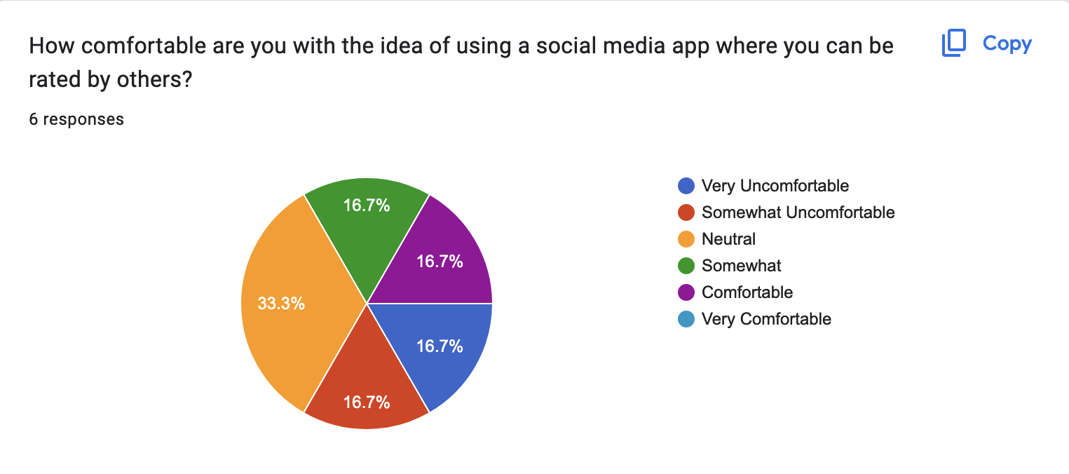

Figure 52. HOW COMFORTABLE ARE YOU BEING RATED BY OTHERS?

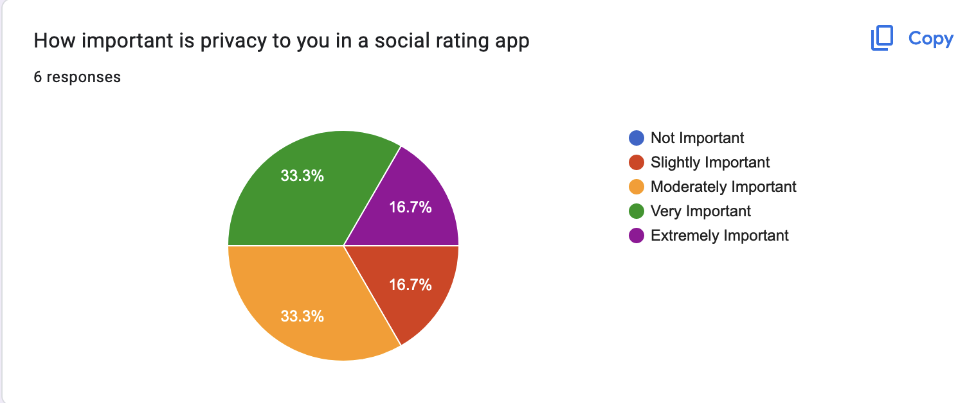

Figure 53. How important is a social rating app.